FS-201超强力翅片除油清洗＆抛光剂 （铝威）
Super-power cleaning agent for fins use&polishing agent (Aluminum Wei)
弗兰士系列产品受助于美国陶氏化学技术支持，及原材料供给，优化了产品质量.铝威空调专用翅片碱性除油脂、除锈膜、除尘清洗产品。
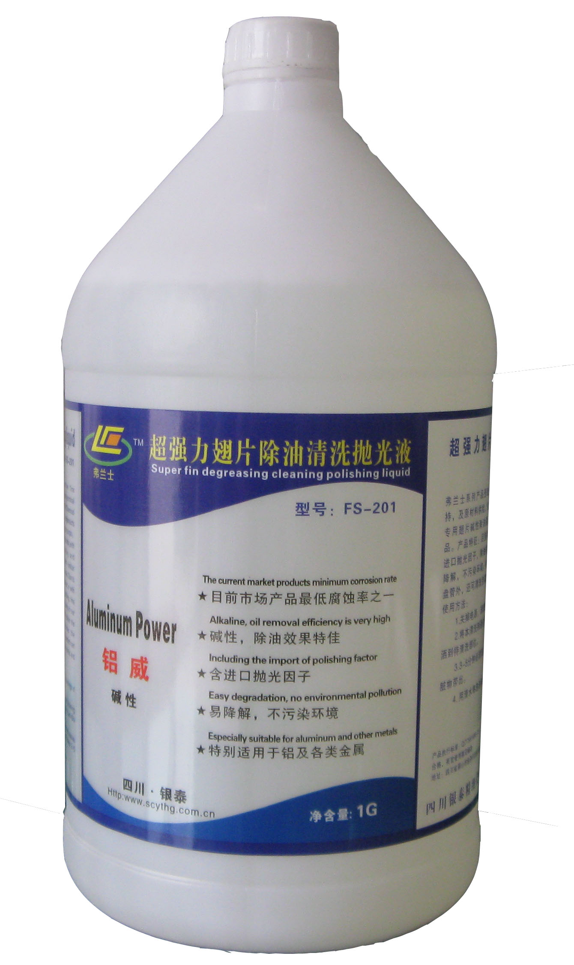
产品特征：目前同类产品腐蚀率最低；含进口抛光因子，除油效果佳，洗后光洁发亮, 产品能被降解，不污染环境。除蒸发器、冷凝器、翅片盘管外，还可清洗空调外壳、过滤网等。
使用方法：
- 关掉电源，清理空调外部环境！
- 将本清洗剂通过弗兰士专用喷壶，均匀喷洒到待清洗部位。
3. 3-5分钟后清洗剂发泡自动将油污及氧化脏物带出。
4. 用清水将泡沫和残留物清洗干净。
Fu Lanshi series recipients in the U.S. Dow Chemical technology support and supply of raw materials, to optimize product quality. Aluminum Viagra air conditioning fin alkaline addition to the grease, rust film, dust cleaning products.
Product Features: similar products in the lowest corrosion rate; including import factor of polishing, degreasing effect, washed, smooth and shiny, the product can be degraded, do not pollute the environment. In addition to the evaporator, condenser, finned coil, but also cleaning the air-conditioned enclosure, filters and so on.
How to use
1, Turn off the power to clean up the air conditioning external environment
2, the cleaning agent by Fu Lanshi special watering can, spray evenly to be cleaning parts.
3,3-5 the points Zhong Houqing lotion foam automatically with oil and oxidation dirt out.
With water, foam and residue clean.

FS-202强力翅片除垢清洗＆抛光剂（铝耀）
Super power scale-remover for fins use & polishing agent(Aluminum Yao)
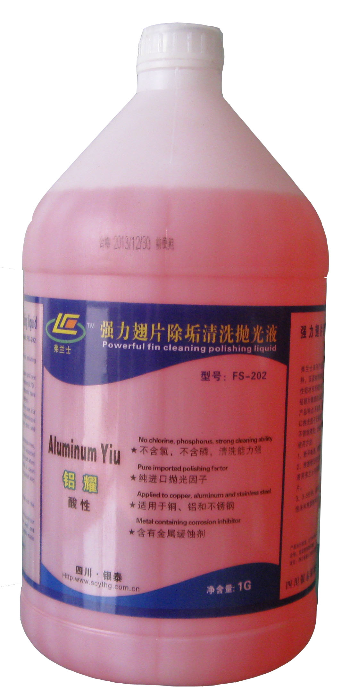
弗兰士系列产品受助于美国陶氏化学技术支持，及原材料供给，优化了产品质量。铝耀酸性铝材专用清洗剂.用于清洗空调室外机外壳及铝翅片集结的尘垢及氧化物。
产品特点:不含氯、不含磷、清洗力强、选用进口抛光因子及表面活性剂, 适用于铝，铜、铁、不锈钢清洗；含金属缓蚀剂。
使用方法:
1、断开电源，做好空调外部环境清理。
2、根据情况可先用水喷湿翅片或直接将本清洗液用弗兰士专用
喷壶喷至待清洗外壳及翅片。
3、3-5分钟，待清洗发泡完成，用清水将泡沫和残留物冲洗干净。
Fu Lanshi products recipients in the U.S. Dow Chemical technology support and supply of raw materials, to optimize product quality.Grime and oxides of aluminum Yiu acidic aluminum cleaning solvents used for cleaning air conditioning outdoor unit shell and aluminum fin assembly.
Features: chlorine, phosphate, clean and strong selection of imported polished factors and surfactants, for aluminum, copper, iron, stainless steel cleaning; metal corrosion inhibitor.
How to use:
1 Disconnect the power supply, good air conditioning external environmental clean-up.
2, the first water spray fin or the cleaning fluid directly Fu Lanshi special watering can spray to be cleaning the shell and fin.
3,3-5 minutes until the cleaning foam to complete the foam and residue rinse with water.
FS-204 室内机风道清洁杀菌除味剂(康力福)
Deodorant with the function of disinfection and cleaning the air duct of indoor air-Conditioner
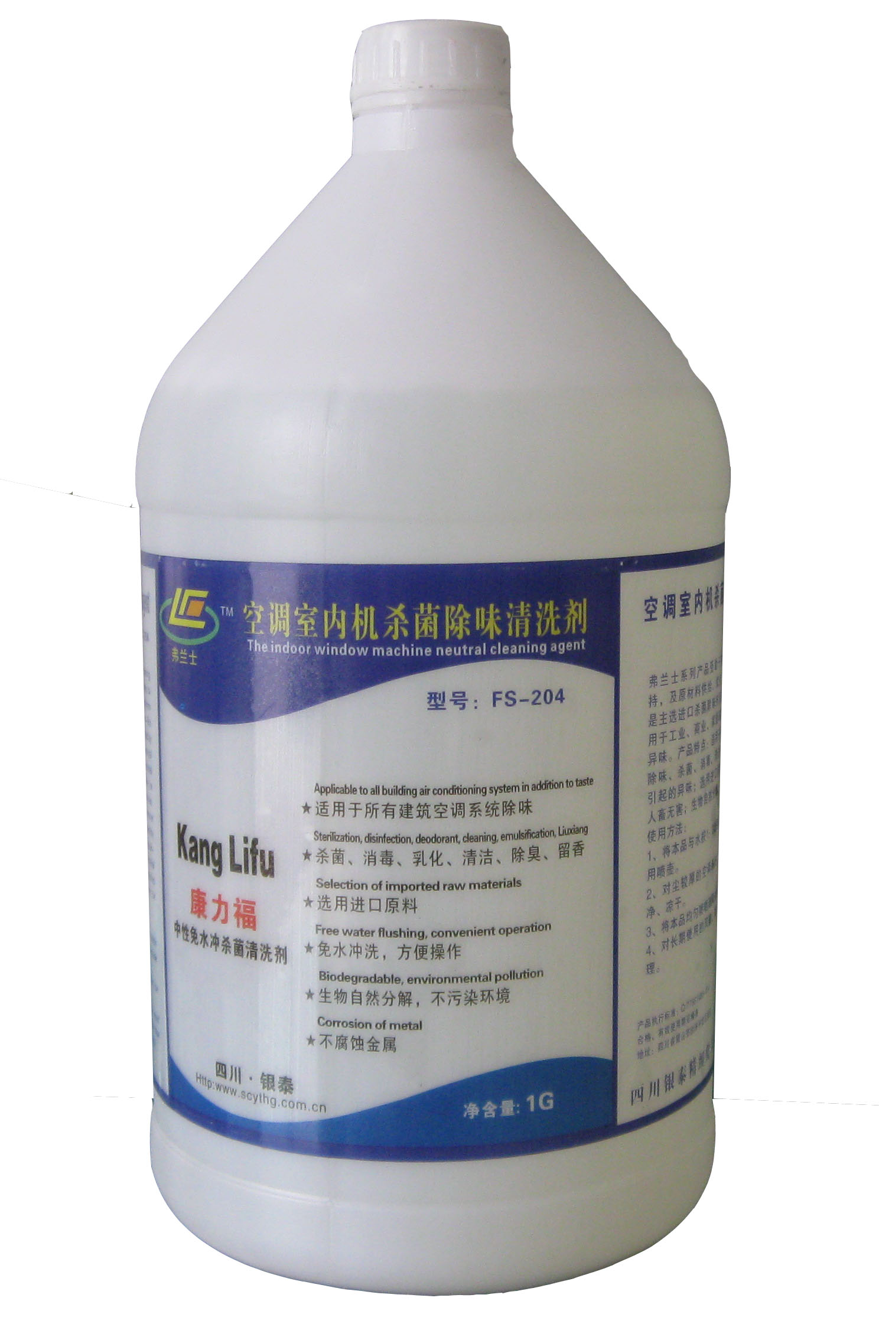
弗兰士系列产品受助于美国陶氏化学技术支持，及原材料供给，优化了产品质量。康力福是主选进口杀菌除味剂及乳化活性剂合成，适用于工业、商业、家居环境的杀菌、消毒除异味。产品特点：适用于所有建筑空调系统、除味、杀菌、消毒、清洁；去除由细菌、霉菌引起的异味；选用进口原料；不腐蚀金属，对人畜无害；生物自然分解，不污染环境。
使用方法：
1、将本品与水按1：3比例稀释，盛入弗兰士专用喷壶。
2、对尘较厚的空调系统，应先清理和冲洗干净、凉干。
3、将本品均匀喷哂到风道系统的每个角落。
4、对长期使用的风道、蒸发器等应每月一次处理。
Fu Lanshi products recipients in the U.S. Dow Chemical technology support and supply of raw materials, to optimize product quality.Kangli Fu is the main election import Sterilization odor or emulsifying surfactant synthesis, applicable to industrial, commercial, and home environment of sterilization and disinfection in addition to smell.Features: Applicable to all building air conditioning system, in addition to smell, sterilization, disinfection, cleaning; remove the odor caused by bacteria, fungi; selection of imported raw materials; non-corrosive metal, harmless to humans and animals; natural biological decomposition, do not pollute the environment.
How to use:
1, the product with water ratio of 1:3 dilution, Sheng Rufulanshi special watering can.
2, the dust-thick air-conditioning system should first clean and rinse, dry.
3, the goods will be evenly sprayed contempt to every corner of the duct system.
4, long-term use of the duct, the evaporator should have a monthly one
FS-501运行除垢灵（神鹰克垢）【不停机除垢】（Detergent for running air-conditioner use）
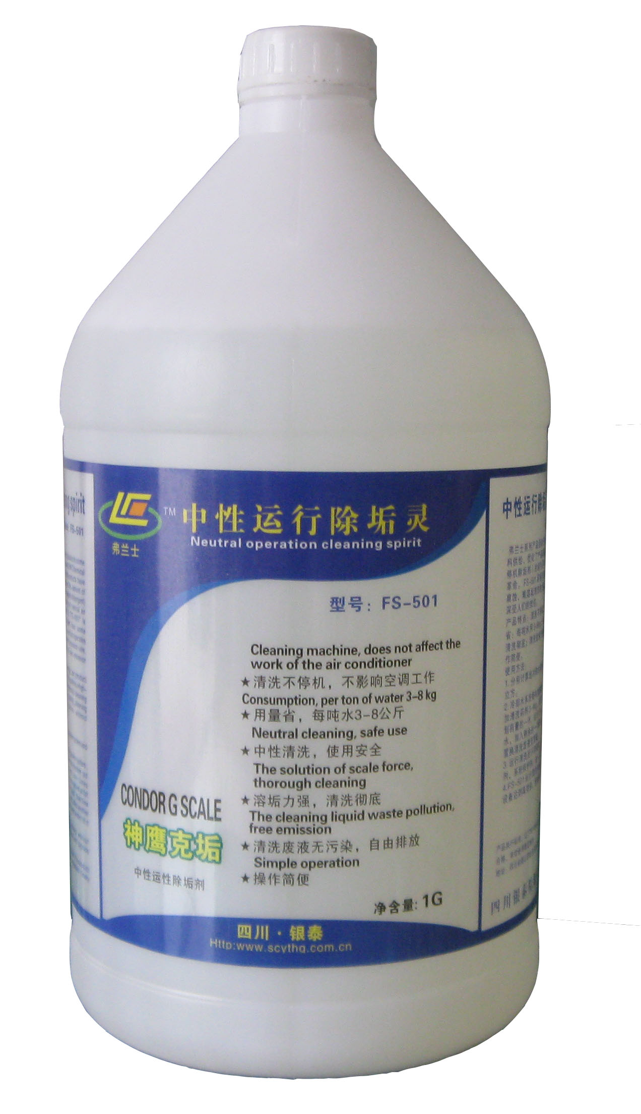
弗兰士系列产品受助于美国陶氏化学技术支持，及原材料供给，优化了产品质量。神鹰克垢（运行除垢灵、不停机除垢灵）的诞生是中央空调循环水系统清洗的一次革命。FS-501因操作简单，用量省，PH值中性，腐蚀率极小，难溶垢清洗能力强，废液自由排放等诸多优点而受人们的欢迎。
产品特点：1、清洗不停机，不影响空调系统工作。
2、用量省：每吨水用3-8kg
3、中性清洗，使用安全
4、溶垢力强，清洗彻底。
5、清洗废液无污染，自由排放。
6、节省预膜，操作简便。
使用方法：
1、分别计算出冷却水系统容水立方，冷冻水系统的容水立方。
2、冷却水系统每吨加清洗药剂5-8kg，冷冻水系统每吨加清洗药剂3-4kg，分别分两次加入。第一次加入计划药量的一半，运行15天后，排放一半污水。再补足清水，加入剩余的一半药剂，再运行10-20天后，用清水置换清洗废液至清澈。
3、运行清洗后不用预膜，可加入杀菌灭藻剂、缓蚀阻垢剂，系统进入正常运行。
4、FS-501运行清洗剂根据结垢状况可适时清洗，实现设备达到高效益、低成本运行。
Fu Lanshi products recipients in the U.S. Dow Chemical technology support and supply of raw materials, to optimize product quality.Eagle g scale (running the descaling spirit kept the birth of the machine the descaling spirit) is a revolution of the central air conditioning circulating water system cleaning. FS-501, simple operation, the amount of provincial, PH value neutral, minimal corrosion rate of the cleaning ability of insoluble dirt, waste free emission of the many advantages of welcome by the people
Product Features:
1,Cleaning without stopping the machine, does not affect the air-conditioning system.
2, the amount of Province: ton of water, using 3-8kg
3, neutral cleaning, use of safety
4, dissolve dirt and strong, clean thoroughly.
5, cleaning waste pollution-free, free emissions.
6, to save the pre-film, easy to operate
How to use:
1, respectively, calculated cooling water system capacity Water Cube, the chilled water system capacity Water Cube.
2 per ton of cooling water system and cleaning Pharmacy 5-8kg per tonne of chilled water system, plus cleaning agents 3-4kg, respectively, the two join. Add half of the planned dose for the first time, run 15 days after the emissions from half of the sewage. Make up the water, add the remaining half of Pharmacy, and then run 10-20 days, cleaning of waste water to clear water replacement.
3,Run after cleaning without pre-film, can be added to the biocide agents, corrosion inhibitors, and the system into normal operation.
4, FS-501 running the cleaning agent according to the scaling condition can be timely cleaning, realization of the device to achieve high efficiency, low-cost run.
FS-502 超强彩码除垢剂（克垢丹）（Super ColorCode Detergent）
弗兰士系列产品受助于美国陶氏化学技术支持，及原材料供给，优化了产品质量。克垢丹是
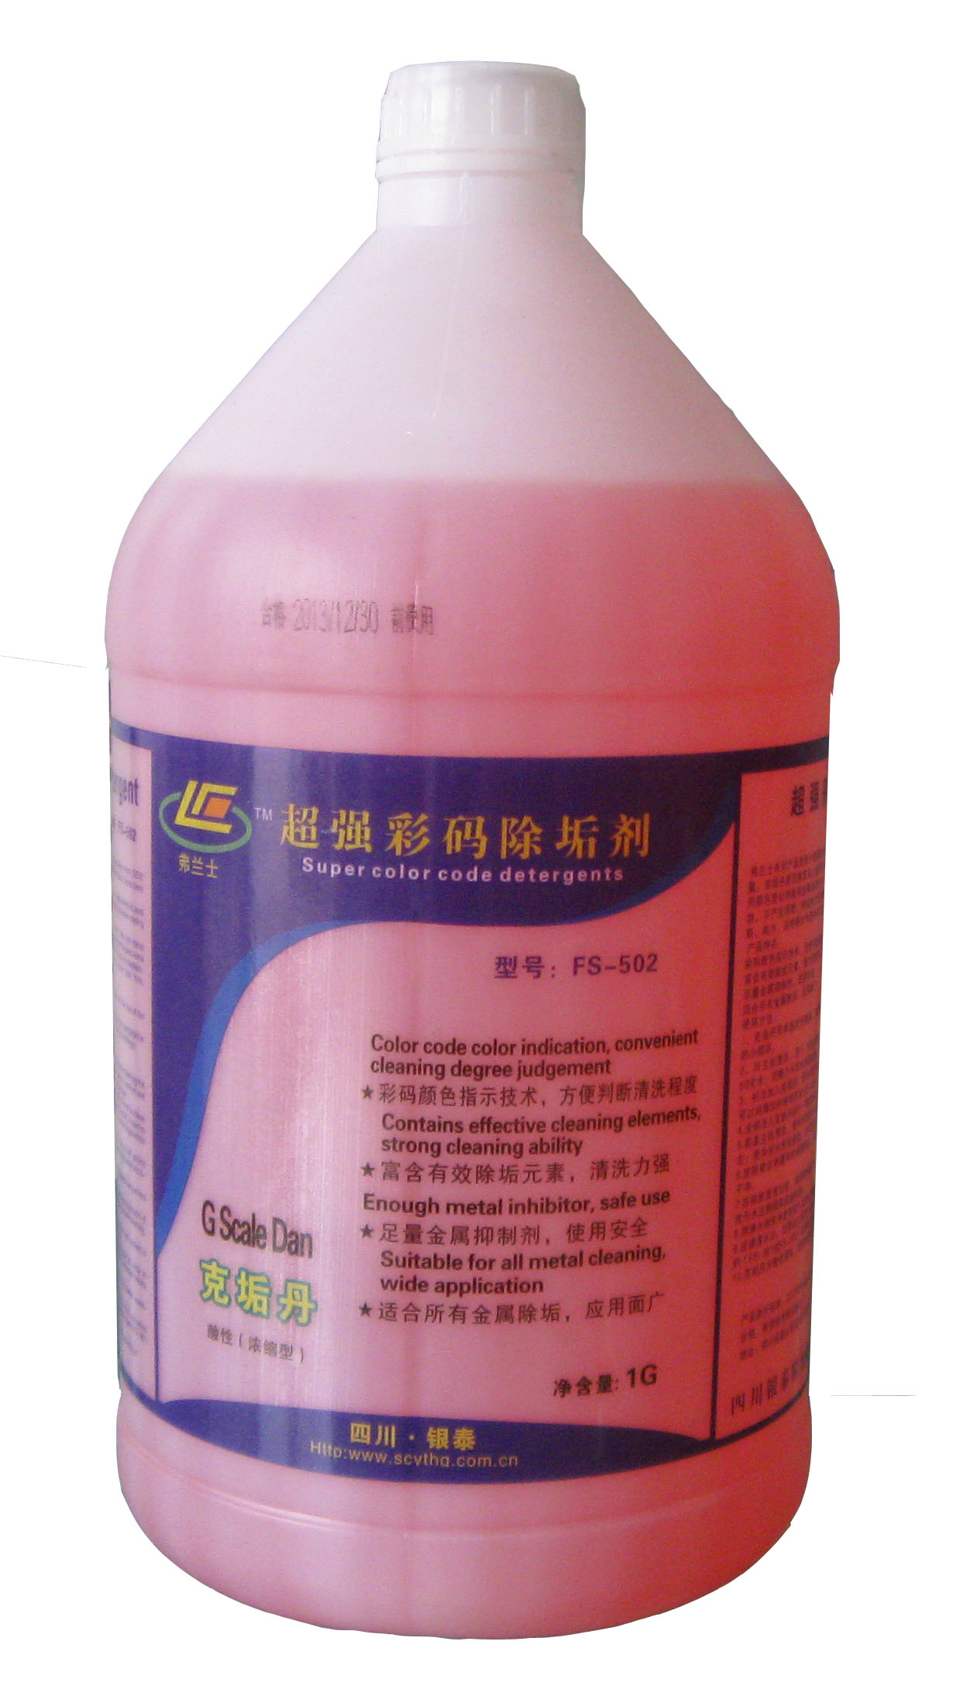
目前市场上循环冷却塔、换热器及管道水垢清除最有效产品。采用颜色变化判断系统除垢是否干净；富含金属缓蚀剂，可保证金属部件不受腐蚀，不产生回锈；除垢能力强等特点。可用于开利，特灵、约克、三洋、奥克斯、格力、谷轮等大中型中央空调及冷冻系统。
产品特点：1、彩码颜色指示技术，方便判断清洗程度；
2、富含有效除垢元素，强力清除石灰，钙镁盐沉淀、
二氧化硅、锈氧化物等；3、足量金属抑制剂，使用
安全，适合所有金属除垢，应用面广。
使用方法：
- 克垢丹可单独对冷凝器、蒸发器、换热器除垢，采
用外接循环泵，配液槽的小循环。
2、对主机清洗，用1：10到20倍兑水；对整个冷却水系统清洗，用1：30到50兑水；对整个冷冻水系统清洗，用1：100到1：150兑水。
3、初次加入克垢丹，排水将呈黄色或其他颜色；为防止药水反应速度过快，可以间隔30分钟将药水分3-4次加入。
4.全部注入克垢丹运行一段时间后，会发现PH值较投放初期明显变高。
5.若是主机清洗，循环时间在4-8小时左右；若冷却水清洗，6-12小时左右；若冷冻水清洗，约12到24小时。
6.按照建议剂量和时间循环后，若再次加入克垢丹，水变成红色，表明已清洗干净。
7.在排除废液以前，请用氢氧化钠或苏打粉中和至PH值7-8，这样可以保证排放污水达到国家排放标准。
8.用清水彻底冲洗系统1-2次以去除所有残留
9.注满清水后，定期加入弗兰士缓蚀阻垢分散一体剂（FS-601）和微生物杀灭剂（FS-301或FS-302）以便保养系统。
10.克垢丹为酸性液体，使用时防止接触皮肤。
Fu Lanshi products recipients in the U.S. Dow Chemical technology support and supply of raw materials, to optimize product quality. Grams of dirt Dan
Currently on the market cycle cooling towers, heat exchangers and pipe scale to clear the most effective products. Color change to determine whether the system descaling clean; inhibitor of metal-rich to ensure that metal parts from corrosion, does not produce back to rust; descaling ability and other characteristics. Carrier, Trane, York, Sanyo, Oaks, Gree, Copeland and other large and medium-sized central air conditioning and refrigeration systems can be used.
Features: 1, the color of the color code indicates the technology, to facilitate the judgment of cleaning levels.
2,Rich in effective descaling elements, strong clear lime, calcium and magnesium salt precipitation, silica, rust oxide.
3, sufficient amount of metal inhibitors, the use of security. Suitable for all metal cleaning, and a wide range of applications.
How to use:
1, g scale Dan alone descaling of condensers, evaporators, heat exchangers, the use of an external circulation pump with a liquid pool of small cycles.
2, the host cleaning, 1:10 to 20 times watered; cleaning of the entire cooling water system, with 1:30 to 50 watered; cleaning the entire chilled water system, with a 1:100 to 1:150 watered.
3, the initial Jia Ruke dirt Dan, drainage will show a yellow or other colors; to prevent the syrup reaction speed too fast, the medicine water at intervals of 30 minutes 3-4 times to join.
4,All injected g dirt Dan running for some time, you will find the PH value than the early days of launch significantly.
5, If the host cleaning cycle time of 4-8 hours; cleaning of cooling water 6-12 hours; chilled water cleaning, about 12-24 hours.
6,In accordance with the recommended dose and time cycle, again Jiaru Ke dirt Dan, the water turns red, indicating that clean.
7,Before exclude waste, using sodium hydroxide or soda to the PH value 7-8, This will ensure the discharge of sewage to the national emission standards.
8, system. Rinse thoroughly with water 1-2 times to remove all residual
Filled with water, the regularly Fu Lanshi corrosion and scale inhibition and 9,dispersion one agent (FS-601) and microbial biocides (FS-301 or FS-302) for maintenance of the system.
10, grams of dirt Dan acidic liquid used to prevent contact with skin
FS-301 微生物杀菌灭藻剂 [氧化型（浓缩型）]
Microbial bactericide and algicide [oxidation type (concentrated)]
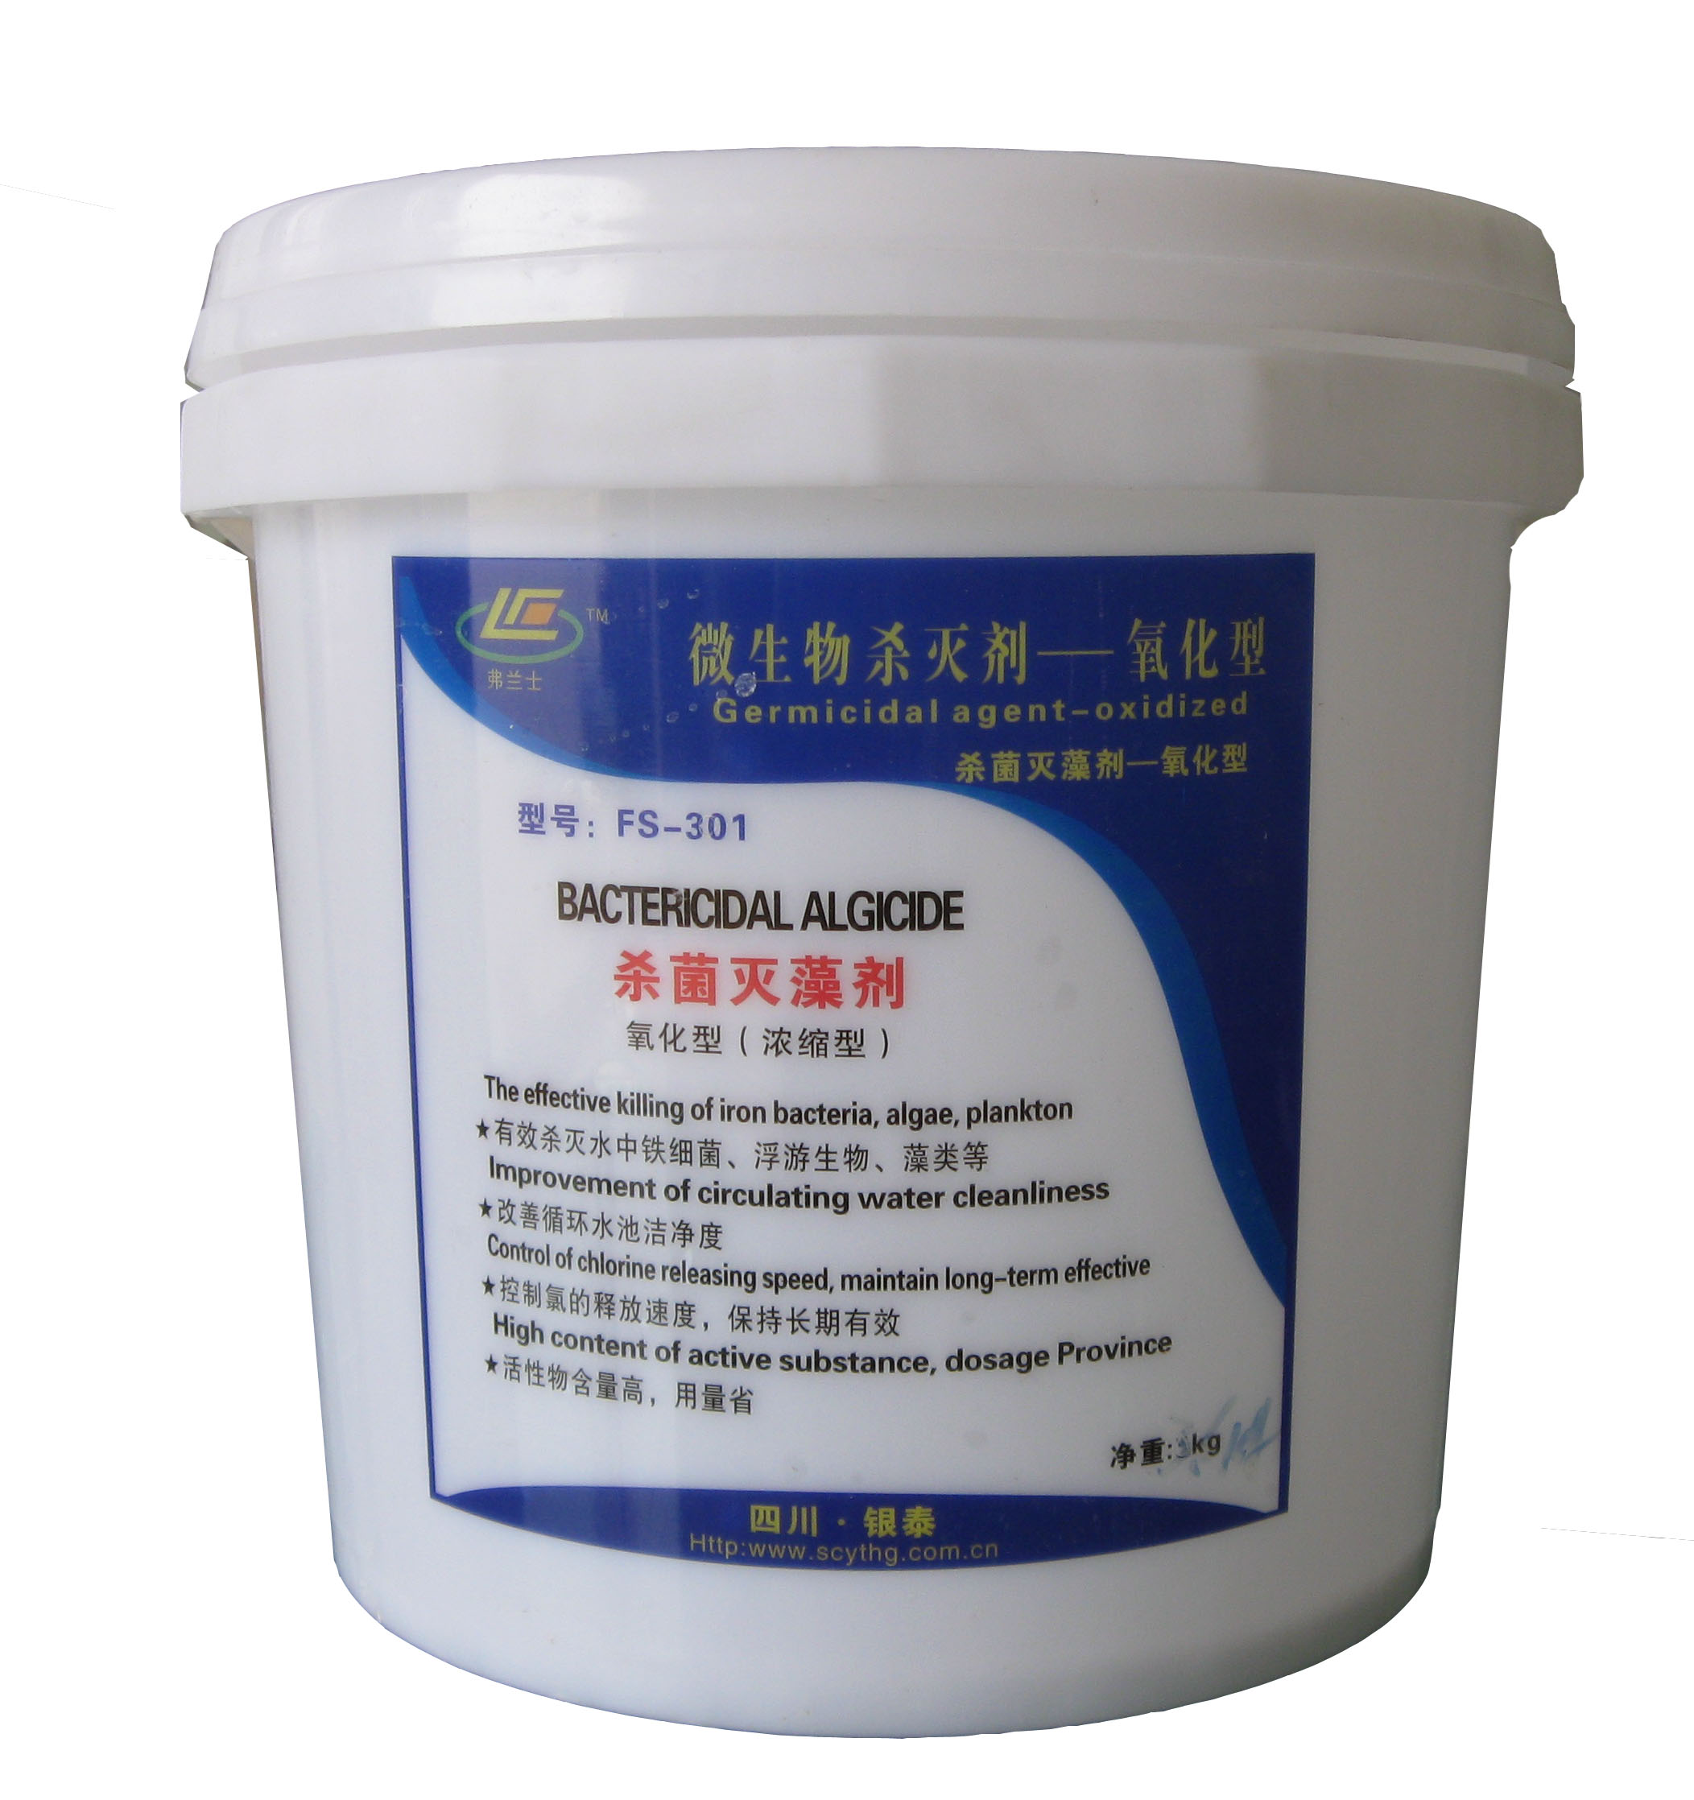
弗兰士系列产品受助于美国陶氏化学技术支持，及原材料供给，优化了产品质量。循环水系统用水因光照温升、蒸发浓缩、溶解氧增加、营养富裕、非常适宜细菌、微生物、藻类等滋生繁衍。导致水质变差，粘泥垢、腐蚀随之增加，影响系统的工作效率和使用寿命。因此微生物杀灭是非常需要的。
产品特点：
1、有效杀灭水中铁细菌、浮游生物、藻类等
2、改善循环水池洁净度
3、控制氯的释放速度，保持长期有效
4、活性物含量高，用量省
使用方法：
1、计算出池水保有水量，采用冲击式投放。
2、根据池水浊度大小，FS-301每立方投加50g-100g本品；投加周期每周投加一次。
3、本品为氧化性药剂，建议与非氧化性药剂FS-302交替使用。
Fu Lanshi products recipients in the U.S. Dow Chemical technology support and supply of raw materials, to optimize product quality.The circulating water system water temperature rise due to illumination, evaporation, dissolved oxygen increases, affluent nutrition is very suitable for the breeding of reproduction of bacteria, microbes, algae. Resulting in deterioration of water quality, sticky dirt, corrosion increases, affecting the system's efficiency and service life. Microbial kill is very much needed.
Product Features:
1, effectively kill the water, iron bacteria, plankton, algae, etc.
2, to improve the cleanliness of the recycling pool
3, control the release rate of the chlorine, to maintain long-term effective
4, the active matter content, the amount of Province
How to use:
One to calculate the water to maintain water, the use of the launch of Impact.
2, according to the water Turbidity size, the FS-301 per cubic dosing 50g-100g of this product; dosing cycle weekly dosing.
3, product oxidation agent, recommendations, and non-oxidizing
agent FS-302 are used interchangeably
FS-302 微生物杀菌灭藻剥离剂 [非氧化型（浓缩型）]
Microbial stripping agent for sterilization and algicide [ non-oxidation type (concentrated)]
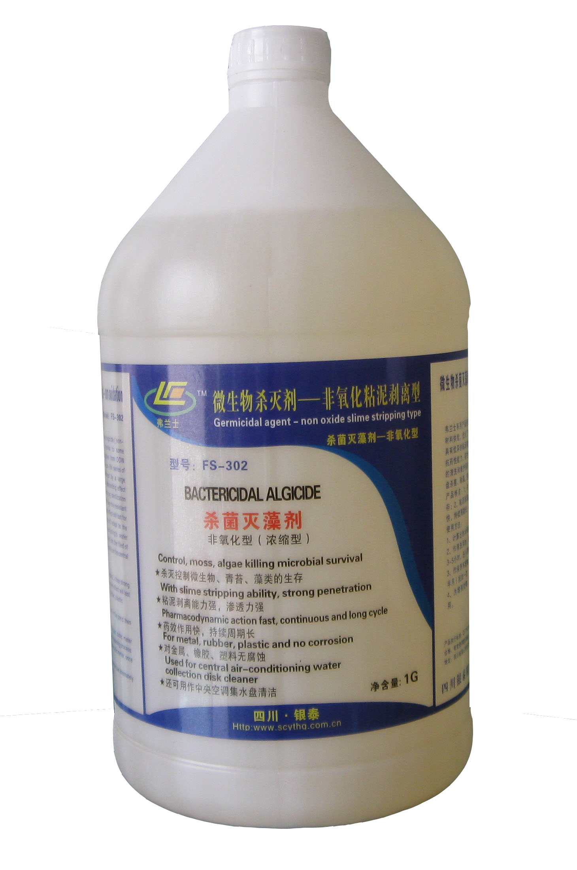
弗兰士系列产品受助于美国陶氏化学技术支持，及原材料供给，优化了产品质量。FS-302对循环水系统具有优异的粘泥剥离效果和强力的杀菌能力，不产生抗药性能力，药性持续时间长，适应空调循环水系统的清洗和维护保养。FS-302还可用作中央空调集水盘杀菌、除藻、澄清水质作用。
产品特点：
1、杀灭控制微生物、青苔、藻类的生存；
2、备有粘泥剥离能力，渗透力强；
3、药效作用快，持续周期长；
4、对金属、橡胶、塑料无腐蚀；
使用方法：
1、计算出池水保有水量，采用冲击式投放。
2、作清洗用时，每立方米用300-400g投入本品运行3-5小时，进入清洗程序。
3、作保养系统时，每立方米用100-150g，每周（或半月）投加一次。
4、为增强效果，可与氧化性杀菌剂FS-301交替使用。
Fu Lanshi products recipients in the U.S. Dow Chemical technology support and supply of raw materials, to optimize product quality.FS-302 has the excellent effect of slime stripping and strong bactericidal ability of the circulating water system resistance ability and potency of long duration, air conditioning circulating water system cleaning and maintenance. FS-302 can also be used as a central air conditioning catchment tray sterilization, algae, and to clarify the water quality effect.
Product Features:
1 to kill the control of the survival of microbes, moss, algae;
2, with the slime stripping capacity of the infiltration;
3, pharmacodynamics, long cycle duration;
4, no corrosion of metal, rubber, plastic;
How to use:
One to calculate the water to maintain water, the use of the launch of Impact.
For Cleaning per cubic meter, 300-400g running 3-5 hours put into this product, into the cleaning procedures.
3, for the maintenance system, per cubic meter, 100-150g per week (or a half months) dosing time
4,in order to enhance the effect of oxidizing biocide FS-301 alternating.
FS-601 阻垢缓蚀分散一体剂(Anti-scaling corrosion inhibitors system)
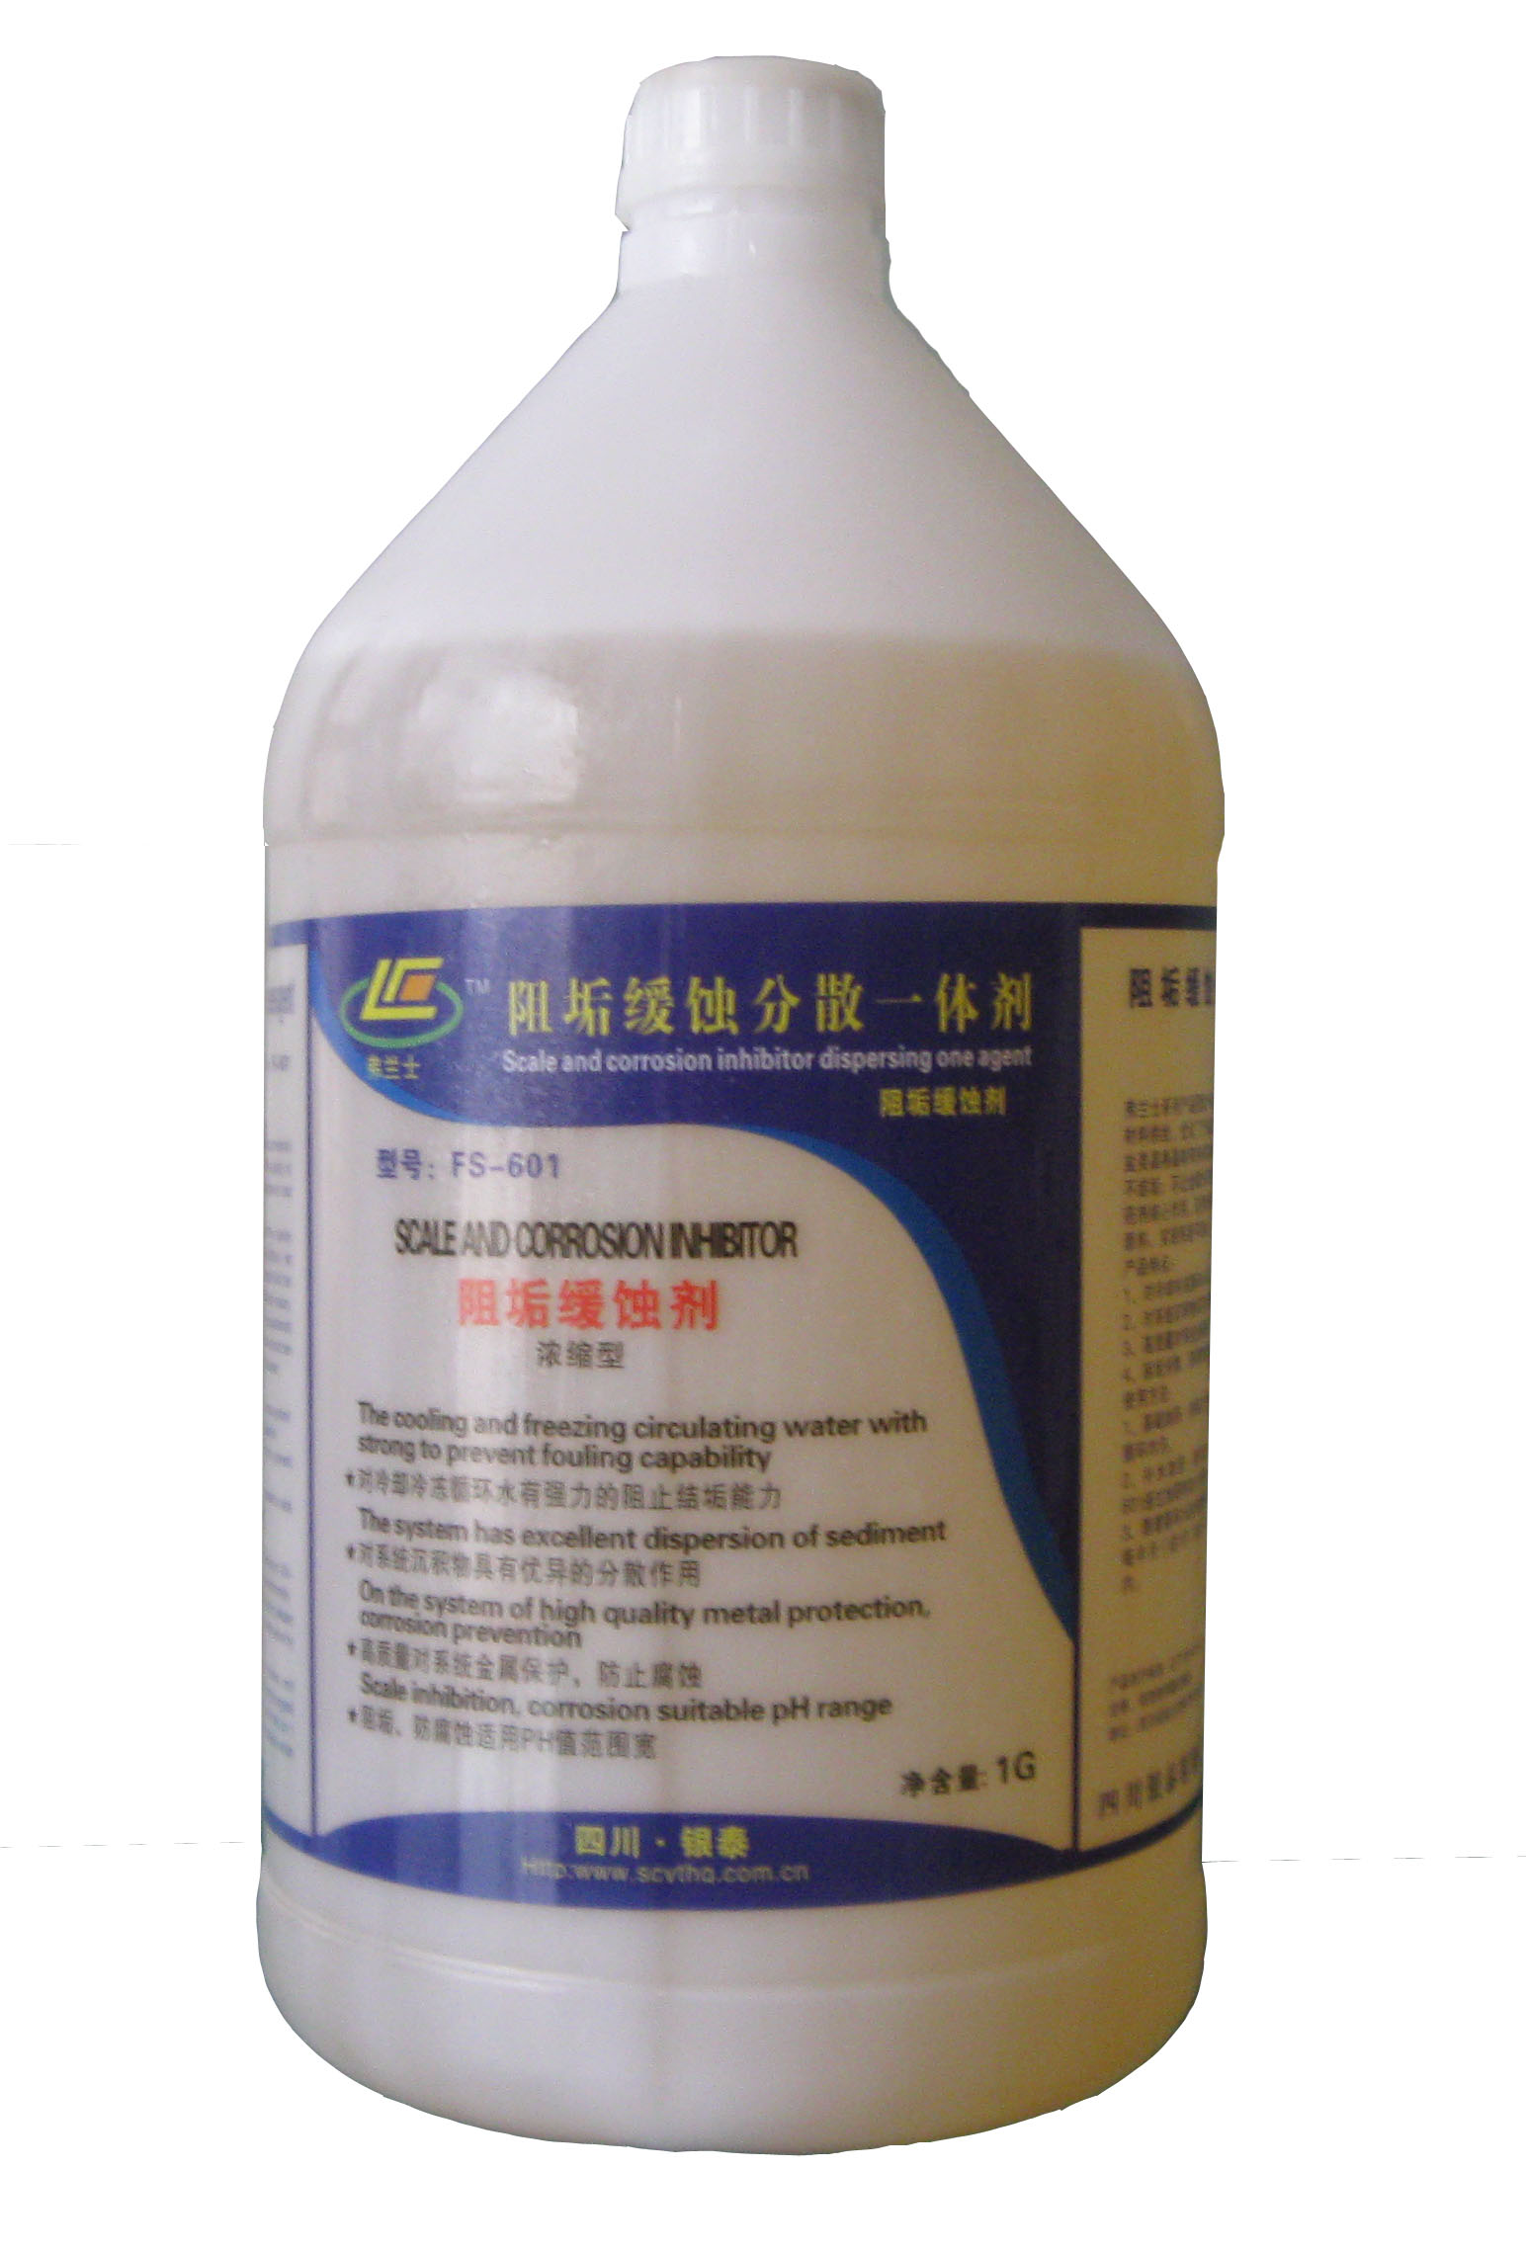
弗兰士系列产品受助于美国陶氏化学技术支持，及原材料供给，优化了产品质量。阻垢分散的目标是破坏盐类晶格晶体有序排列的形成，让水中离子分散均匀不结垢；不让金属外层电子失去而氧化腐蚀，这是本药剂核心作用。采用先进的技术，高科技产品作配方原料，实现系统不结垢，不腐蚀。
产品特点：
1、对冷却冷冻循环水有强力的阻止结垢能力；
2、对系统沉积物具有优异的分散作用；
3、高质量对系统金属保护，防止腐蚀；
4、阻垢分散、防腐蚀性能，适合PH值范围宽。
使用方法：
1、基础加药：按每立方100-150g计量加入循环池，循环均匀。
2、补水加药：新补充水按每立方100-150gFS-601通过加药机加入补水处。
3、随着循环水的浓缩钙镁离子浓度不断增加，建议每半月（或1月）排一次污，控制浓缩倍数在3倍以内。
Fu Lanshi products recipients in the U.S. Dow Chemical technology support and supply of raw materials, to optimize product quality.Scale inhibition and dispersion objective is to undermine the salt lattice crystal ordered the formation of ions in water is dispersed evenly without fouling; not let the metal outer electrons lost to oxidation and corrosion, which is the core role of the pharmaceutical. The use of advanced technology, high-tech products for the formulation of raw materials, to achieve the system does not scale, does not corrode.
Product Features:
A strong cooling refrigerated circulating water to prevent fouling ability;
2, the system sediment excellent dispersion;
3, high-quality system metal protection against corrosion;
Scale inhibition and dispersion, anti-corrosion, suitable for a wide range of PH value.
How to use:
1, based on dosing: per cubic 100-150g metering join the circulating pool, uniform circulation.
2, replenishment of dosing: a new complement of water per cubic 100-150gFS-join the replenishment at 601 dosing machine.
3, with increasing the concentration of calcium and magnesium ion concentration of the circulating water, it is recommended that fortnightly (or January) ranked first pollution control concentrated in
multiples in less than three times
FS-401 金属预膜剂(Prefilming agent)
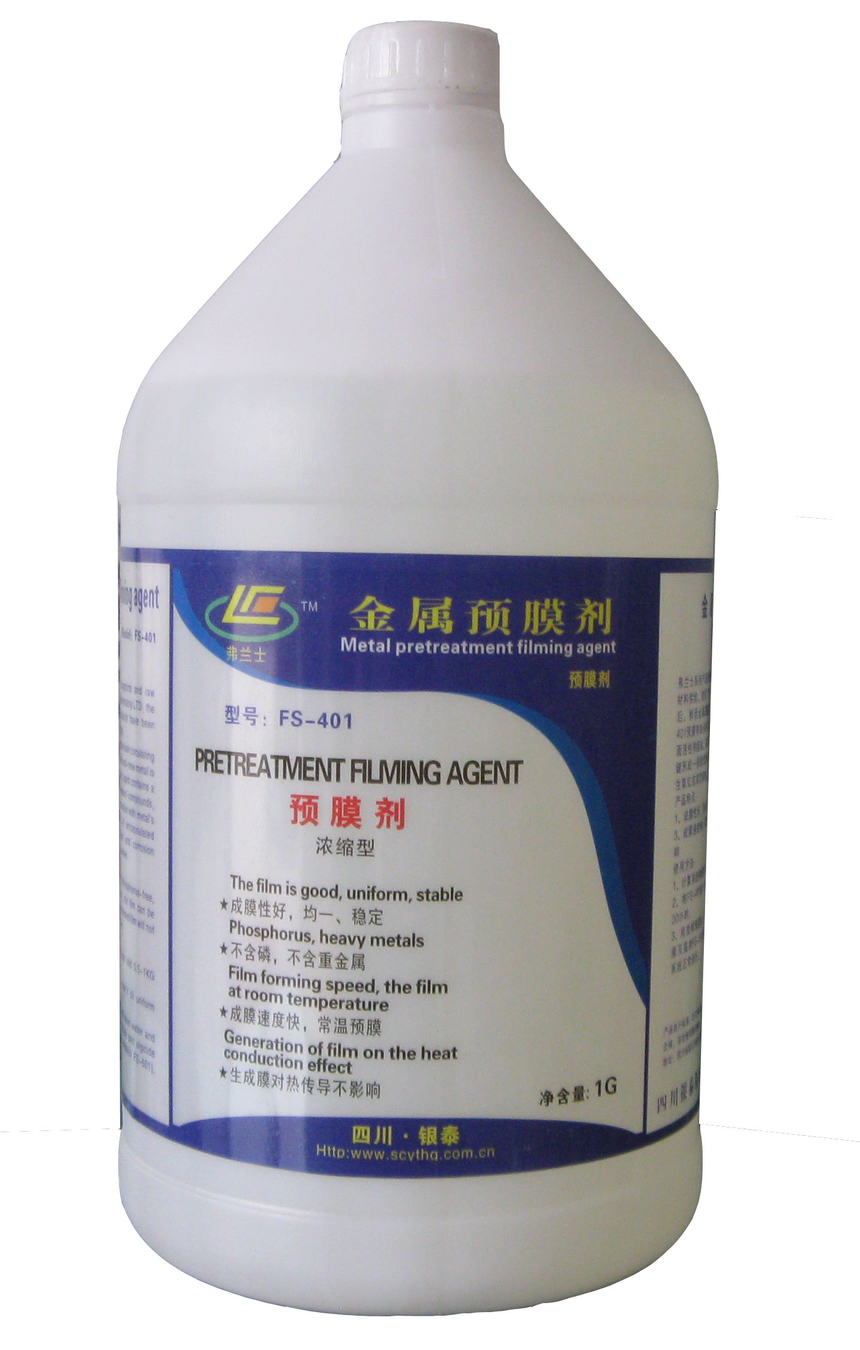
弗兰士系列产品受助于美国陶氏化学技术支持，及原材料供给，优化了产品质量。循环水系统除垢、检修后，鲜活金属暴露易发生氧化，须进行预膜，FS-401预膜剂由多种含氮化合物，络合物、分散剂、表面活性剂组成，能与金属外层电子结合为配位、共价键形成一层致密的保护膜。隔断金属与水中溶解氧发生氧化或其它腐蚀。
产品特点：
1、成膜性好，均一稳定；
2、不含磷，不含重金属；
3、成膜速度快，常温成膜；
4、生成膜对热传导不影响
使用方法：
1、计算系统体积按每立方水加量0.5-1kg。
2、将FS-401投入系统运行至分布均匀，静置20-30小时。
3、排放掉预膜液，补足清水加入系统保护剂，（杀菌灭藻剂FS-301或FS-302、缓蚀阻垢剂FS-601）系统正常运行。
Fu Lanshi products recipients in the U.S. Dow Chemical technology support and supply of raw materials, to optimize product quality.Circulating water system cleaning, maintenance, fresh metal is exposed and prone to oxidation, to carry out the pre-film, the FS-401 pre-filming agent composed by a variety of nitrogen compounds, complexes, dispersing agents, surface active agents, and metalthe outer electron binding ligand covalent bond to form a dense protective film. Cut off the metal and the dissolved oxygen in water oxidation or other corrosion.
Product Features:
1, the film is good, uniform and stable;
2, phosphate, free of heavy metals;
3, film speed, room temperature film;
Generate membrane does not affect the thermal conductivity
How to use:
1, computing system volume per cubic meter of water and 0.5-1kg.
2, the FS-401 system is running to the distribution, and let stand for 20-30 hours.
3,Discharged pre-film liquid to make up the water to the system protection agent (biocide agent FS-301 or FS-302 FS-601), scaleand corrosion inhibitor system uptime

FS-002 空调除菌清洗剂(Cleaner air sterilization)
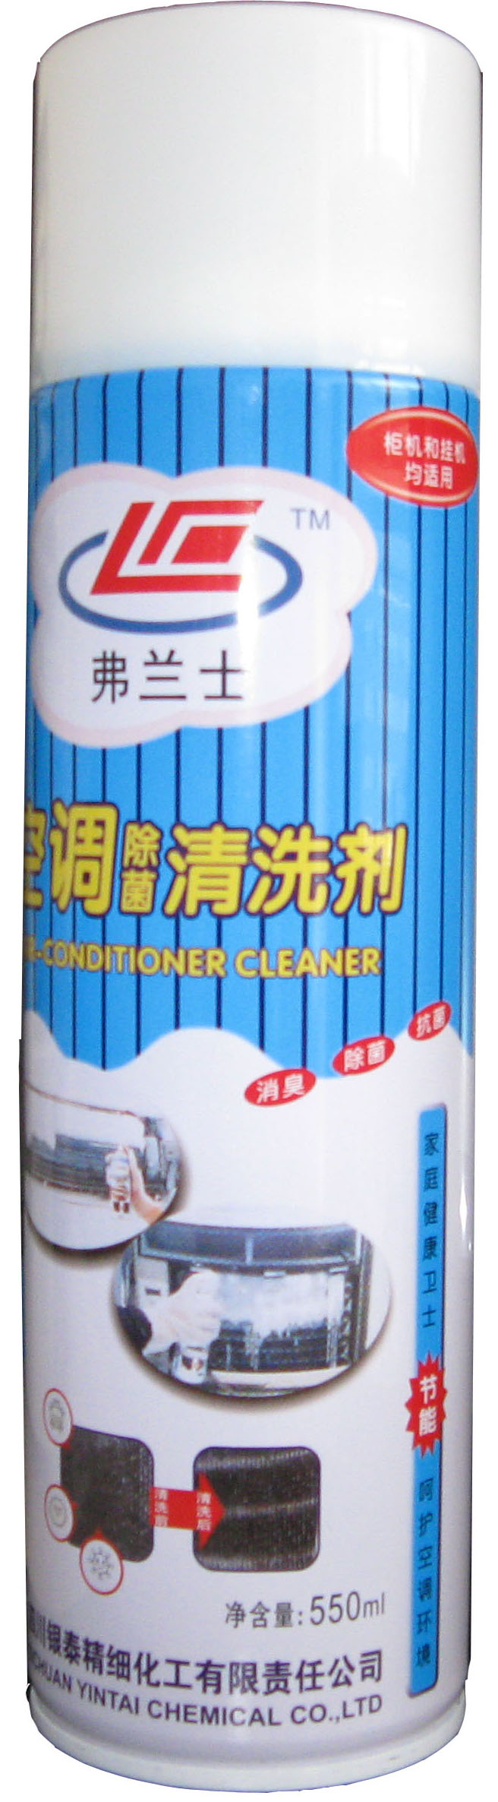
弗兰士系列产品受助于美国陶氏化学技术支持，及原材料供给，优化了产品质量。该产品采用美国陶氏技术及进口原材料精制。能彻底清除空调蒸发器、风机上附着的各种细菌、臭味、毒素及尘垢。本清洗剂免水冲洗，操作简单，便于家庭操作。
使用范围：各种柜机和挂机。
注意事项：本品属压力容器制品，易燃，遵守以下事项
- 使用时保持室内空气流通；
- 勿让儿童接触，不要喷向面部及眼睛；
- 操作时戴上胶手套；
- 远离火源及高温物件、勿刺穿空罐；
- 贮存于通风透光阴凉处，储存温度低于45℃，避免阳光直照。
产品规格：550ml
Fu Lanshi products recipients in the U.S. Dow Chemical technology support and supply of raw materials, to optimize product quality.The product is refined Dow technology and imported raw materials. Can completely remove the air conditioning evaporator fan attached to a variety of bacteria, odors, toxins, and grime. Free water, rinse the cleaning agent, simple operation, easy family operation.
Use: all kinds of Guiji, and hang up.
Note: This product is a pressure vessel products, flammable, observe the following
★ use to maintain good indoor ventilation;
★ do not let children, do not spit the face and eyes;
★ operations to wear rubber gloves;
★ Keep away from sources of ignition and hot objects, do not pierce the cans;
★ storage, storage temperature is below 45 ° C in the air and light shade and avoid direct sunlight.
Product Specifications: 550ml

FS-702 空调冷媒管道清洗剂（Air-conditioning refrigerant pipe cleaners）
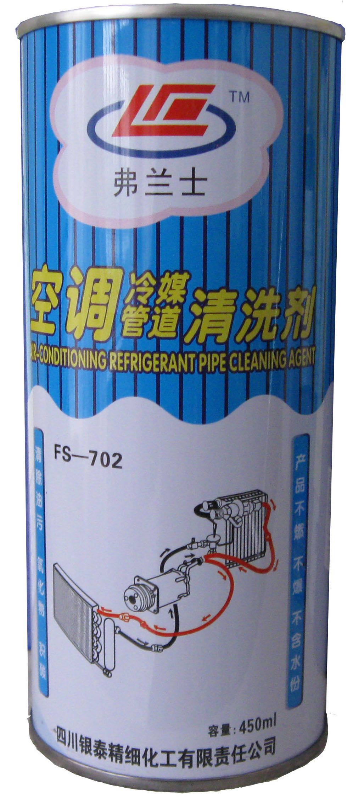
弗兰士系列产品受助于美国陶氏化学技术支持，及原材料供给，优化了产品质量。
弗兰士冷媒管道清洗剂是强溶剂性复合产品。当压缩机长期
工作产生磨损、漏油、烧毁，在检修完成时必须对制冷剂管
道清洗后才能投入正常运行。本剂可清洗溶解烷基苯油、矿
物油、氧化物积碳、潮气及粘状物等，使用后彻底清洁污物，
恢复空调性能。
使用方法：将FS－702注入待清洗的冷媒管道中，静泡或采
用循环清洗，5-10分钟后，用氮气或干燥空气将清洗溶剂
吹出。然后将冷媒管道与压缩机系统连接起来。对大系统
可将冷凝器、蒸发器分开来独立清洗。
注意事项：操作时在通风处进行，保存于阴凉干燥处，远
离小孩。
Fu Lanshi products technical support recipients in the U.S. Dow Chemical, and raw material
supply, optimize product quality.
Fu Lanshi refrigerant pipe cleaners is a strong solvent compound products. When the compressor produces long-term wear and tear, oil, burned in complete overhaul of the refrigerant piping must be cleaned before put into normal operation. The cleaning agent can be dissolved in benzene oil, mineral oil, oxides of carbon, moisture and sticky bar, etc., after use, thoroughly clean the dirt and restore air conditioning performance.
Usage: The FS-702 into the refrigerant pipe to be cleaned, or using static foam cleaning cycle, 5-10 minutes later, with nitrogen or dry air will blow cleaning solvent. Then the refrigerant pipe connected with the compressor system. For large systems the condenser, evaporator separate independent cleaning.
Note: in the ventilation operation conducted, stored in a cool dry place, away from children

FS—029 空调管道检漏液
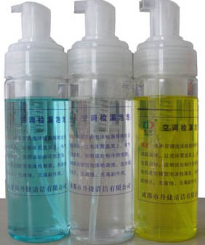
将本空调泡沫检漏液喷向空调疑漏处，让泡沫覆盖其上，有气泡冒出处，说明该处制冷液泄漏。本剂是防锈型泡沫检漏液，泡沫细腻持久，无腐蚀，无毒副作用。

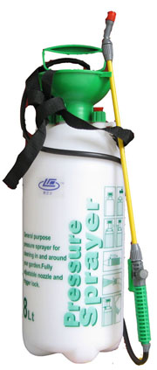
FS—030 空调清洗喷雾壶
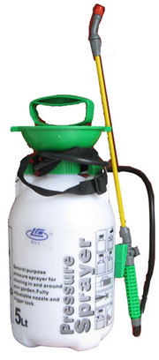

5升
8升

