QD-1000中封单膜液体包装机
一、主要特点：
本机是我厂开发制造的立式、三边封合、间歇式高精度液体包装机。制袋、充填、封合、打印批号、切断、计数等全过程自动完成，微处理器控制，光电眼自动跟踪色标，定位准确可靠，是目前国内最先进的液体物体，尤其适用酱油、酒、醋、果汁饮料、配制饮料、豆奶、牛奶、花生油、菜油及各种植物油、矿泉水和液体化工产品的单膜或复合膜袋状。

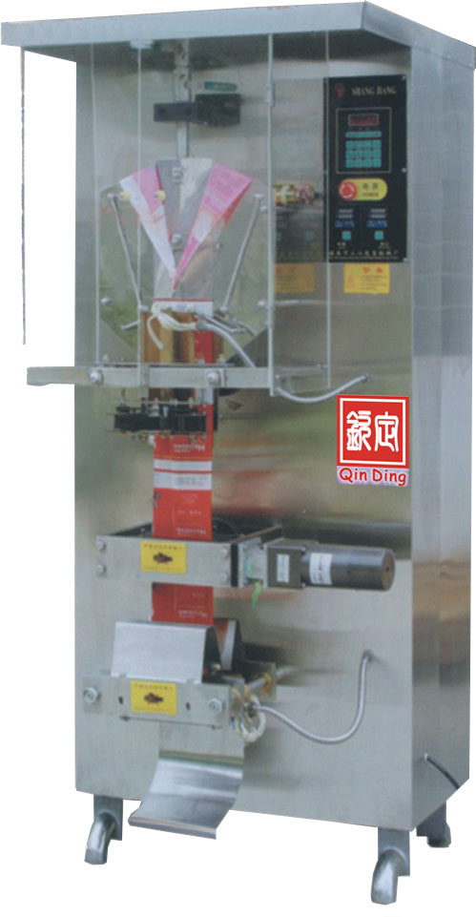
二、性能参数：
型号 | QD-1000
生产速度 | 1800Bags/H
包装容量 | 50～500ml、1L
电源电压 | AC220V/50Hz AC380
供纸电机 | 25W/220V
热封功率 纵封/横封 | 300W/500W
电机功率 | 370W/380V/220V
外形尺寸 | 950× 800×2000 mm
整机重量 | 300Kgs
型号 | QD-1000

QD-1000middle seal single and compound film packing machine
I．Main characteristic
This machine is a vertical type machine,it seal three sides, intermittent high-accuracy liquid packing machine.It can automatic complete the full process of bag-making,fill,seal,print number,cut and counting and so on,be controlled by microprocessor,the photoelectricity eye automatic track colour code , allocated accurately and reliablely , it is the most advanced liquid object in domestic market at present,especially suitable to pack the single and compound films,such as pack sauce,liquor,vinegar,soft drinking,soymilk,milk,peanut oil,vegetable oil,and various plant oil , mineral water and liquid chemical products.
II．Performance parameter
Model | QD-1000
Speed | 1800Bags/H
capacity | 50～500ml、1L
power | AC220V/50Hz AC380
Confession paper electric motor | 25W/220V
heat-seal power longitudinal seal/ transversal seal | 300W/500W
Hotor power | 370W/380V/220V
Outline dimension | 950× 800×2000 mm
Machine weight | 300Kgs
公司电话：021-69512689 传真：021-69522685
手机：13120714901张振伟 网址：www.qindianpack.com

