QD-60B颗粒自动包装机
主要性能和结构特点：
1、背封；
2、可自动完成制袋、计量、下料、封合、分切、计
数、打印批号等功能；
3、采用先进的微电脑控制器，驱动步进电机控制袋
长，性能稳定、调整方便、检测准确；
4、选用智能式温控仪，PID调节，保证将温度的误差
范围控制在1℃以内。
适用于：
膨化食品、虾条、花生、爆米花、麦片瓜子、白糖、调味品等颗粒状、短条状、片状固型物。
制袋尺寸 | 宽:30-140(mm) 长:30-180 (mm)
包装速度 | 30-60袋/分钟
计量范围 | 3-150 ML
电 源 | 220V/50HZ/1.9KW
整机重量 | 400KG
外型尺寸 | 900mm×700mm×1700mm

Main characteristic:
- Back-side sealing. It is called pillow packing machine also.
- It is able to automatically finish the process of bag making, measuring, filling, cutting, sealing, counting and printing series number.
- Adopt advanced microcomputer controller to drive and control the length of bag with stable performance and accurate testing. Meanwhile, it is easy to operate.
- Intelligent temperature controller and PID adjustment make sure the error rage of temperature within 1℃.
Application:
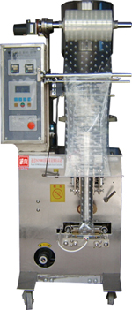
Be used to packing puffed food, shrimp strip, peanut, popcorn, oatmeal, melon seeds, sugar 、tea、and flavoring in the shape of granule, short strip and sheet.
Specification：
Bag Size | (L): 30-180mm;(W):30-140mm
Packing Speed | 30-60bags/min
Measuring Range | 3-150ML
Total Power | 220V/50HZ / 1.9KW
Total Weight | 400KG
Dimension (L×W×H) | 900×700×1700(mm)

