QD-60S输送斗包装机
一、主要特点：
本机可自动完成制袋、计量、充填、封合、商标定位、切断、计数、无级调速等功能。可以根据物料的所需，增加注水等辅助功能。
二、适用范围:
本机适用于食品等行业中较大包且不规则物料的包装，例如螺丝，五金用品，海蜇皮、螺丝、饼干、香皂等物料。
三、性能参数：
机型 | QD-60S(带输送链斗)
制袋容积 | 20～200ml
制袋长度 | 长:40～250mm 宽: 80～280mm
包装速度 | 20～50袋/分钟
整机重量 | 350kg
外形尺寸 | 800×640×1600mm(不含输送带长)
输入电源 | 220V
总 功 率 | 1.6KW
Main performance and structure features:
This machine can automatically complete the processes of bag-making measuring, filling, sealing, trademark location, cutting, counting and stepless adjusting speed. It has the accessory function that it can increase the water according to the requirement of materials.
Application area:
This machine is suitable for packing big bag and irregular foods, such as jellyfish skin, snails, biscuits, soap and so on.
Specification:
Model | QD-60S(with transporting chain)
Bag’s capacity | 20-200(ml)
Bag’s length | L:40-250mm W:80-280mm
Packing speed | 20-50bags/min
Machine weight | 350kg
Outline dimesion | 800*640*1600mm(without length of transporting chain)
Power supply | 220v
Total power | 1.6kw
FOB:25800
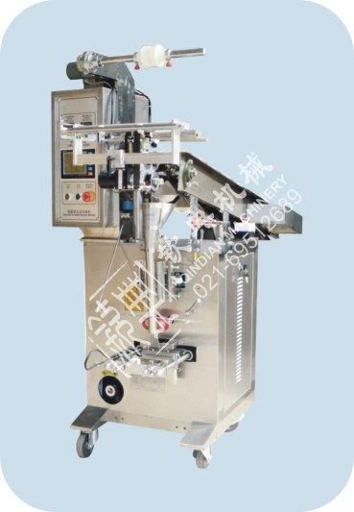
交货时间：收到定金之日起20天内交货
三六一的付款方式

