U型过滤器
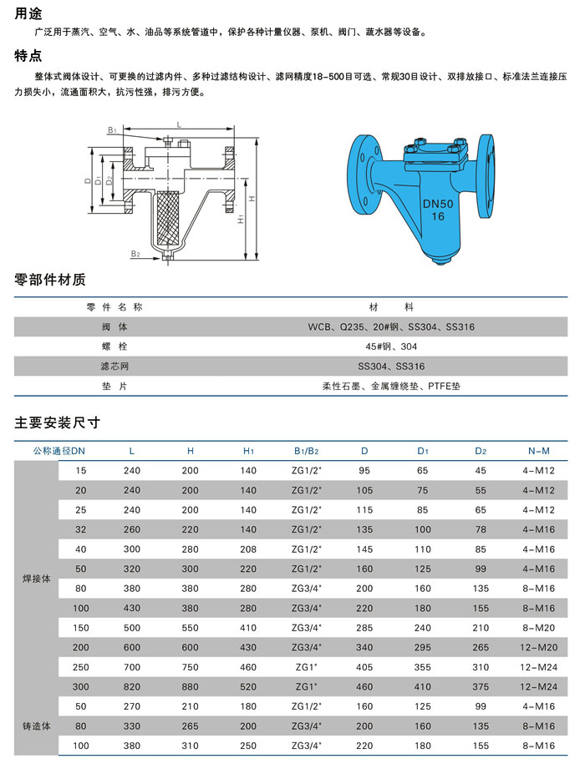

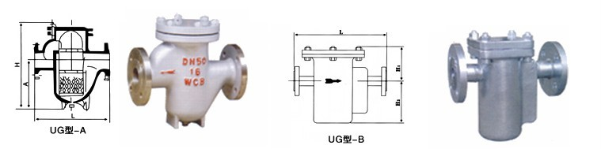

Type  型号 | Nominal Diameter(DN)公称通径 | External dimensions(mm)外形尺寸
Type  型号 | Nominal Diameter(DN)公称通径 | A | L | H
UG型一A | 10 | 150 | 80 | 125
UG型一A | 15 | 150 | 80 | 125
UG型一A | 20 | 180 | 100 | 153
UG型一A | 25 | 180 | 100 | 153
UG型一A | 40 | 200 | 155 | 304
UG型一A | 50 | 300 | 155 | 340
UG型一A | 65 | 340 | 220 | 380
UG型一A | 80 | 400 | 250 | 420
UG型一A | 100 | 500 | 295 | 502
UG型一A | 150 | 600 | 335 | 650
UG型一A | 200 | 786 | 395 | 770
UG型一B | Nominal Diameter(DN)公称通径 | External dimensions(mm)外形尺寸
UG型一B | Nominal Diameter(DN)公称通径 | L | H1 | H2
UG型一B | 15 | 270 | 90 | 145
UG型一B | 20 | 270 | 90 | 145
UG型一B | 25 | 270 | 90 | 145
UG型一B | 32 | 320 | 125 | 175
UG型一B | 40 | 320 | 125 | 175
UG型一B | 50 | 320 | 125 | 175
UG型一B | 65 | 430 | 140 | 220
UG型一B | 80 | 430 | 140 | 220
UG型一B | 100 | 430 | 140 | 220
UG型一B | 125 | 460 | 160 | 235
UG型一B | 150 | 460 | 170 | 235
UG型一B | 200 | 460 | 190 | 235

