
焦作市弘坤阴极保护防腐材料有限公司
Jiaozuo City, Hong Kun cathodic protection corrosion Material Co., Ltd.

目录
Directory

01 公司简介
Company profile
02 牺牲阳极与外加电流的特点
Characteristics of sacrificial anode and applied current
03 镁合金牺牲阳极
Magnesium alloy sacrificial anode
04 填包料 镁带状牺牲阳极
Magnesium ribbon sacrificial anode
05 铝-锌-铟系合金牺牲阳极
Aluminum zinc indium alloy sacrificial anode
08 锌-铝-镉合金牺牲阳极
Zn Al CD alloy sacrificial anode
11 锌带
Zinc belt
12 恒电位仪
Constant potential meter
13 高硅铸铁阳极
High silicon cast iron anode.
14 深井阳极/浅埋阳极
Deep well anode/shallow buried anode
15 贵金属氧化物管状阳极 柔性阳极
Noble metal oxide anode Flexible anode
16 固态去耦合器
Solid state coupler
17 参比电极 极化探头 锌接地电池
Reference electrode Polarization probe Zinc grounding battery
18 铝热焊剂 测试桩
Aluminum heat flux Test pile
19 配套产品系列
Supporting products series
21 工程实例
Engineering example
27 销售网络
Sales network

公司资质
Company qualification
税务登记证 Tax registration certificate
组织机构代码证 Organization code certificate
证书 certificate
营业执照 Business license
商标注册证 Trademark registration certificate
ISO9001认证中文 ISO9001 certification in Chinese
ISO9001认证英文 ISO9001 certification in English

公司简介
Company profile
焦作市弘坤阴极保护防腐材料有限公司位于中原地区的河南省焦作，是专业从事阴极保护材料生产、销售、方案设计、工程施工、技术咨询为一体的新型企业。公司内强管理，规范运作，通过了ISO9001国际质量认证 “中国质量信誉双保障示范企业”、“防腐行业最具影响力品牌”等荣誉。
公司主要经营产品有：镁合金牺牲阳极、铝合金牺牲阳极、锌合金牺牲阳极、镁带、锌带、预包装高硅铸铁阳极、贵金属氧化物阳极、深井阳极、绝缘接头/法兰、热收缩带/套、恒电位仪、测试桩及阴极保护配套产品，镁合金棒、镁合金深加工等上百种规格。
公司建立了一套比较完整的销售和售后服务体系，产品遍布全国20余个省市，公司的产品和技术主要应用于长输管线、石油化工、海洋平台、城市管网、码头钢桩、船舶、储罐等阴极保护工程和变形镁合金挤压生产领域中。在西气东输、各大石化油建建设的防腐工程应用中深受用户好评。出口到苏丹、印度尼西亚、巴基斯坦等国家。
在加入西部大开发的时代背景下，公司以“诚心、用心、创新、感恩”为新契机，建立产、学、研结合的产业化基地，紧紧围绕防腐事业，以管道、油田、码头三个市场为导向，以销售为龙头，以权威的质检平台、技术咨询为核心，以高效的管理体系为保障，以人力资源为根本，整合发展资源，重点持续推进9项高新技术向纵深发展，培养一流的团队，打造一流的精品，以一流的服务为中国乃至世界的防腐事业作出更大的贡献！

Jiaozuo Hong Kun cathodic protection corrosion protection material Company.. is located in the Central Plains area of, Henan Province。It is specialized in cathode protection material production, sales, design, engineering construction, technical advice as one of the new enterprise. Within the company's strong management, standardized operation, we win” the most influential brand in the anti-corrosion industry “and other honors.

The company's main products include: magnesium alloy sacrificial anode, aluminum alloy sacrificial anode, zinc alloy sacrificial anode, magnesium, zinc, pre packaged high silicon cast iron anode, your metal oxide anode, deep well anode, insulation joint / flange, thermal contraction belt / sets, constant potential instrument, testing pile ,cathodic protection products and other hundreds of supporting specifications.

Company has established a complete sales and after-sales service system .Our products throughout more than 20 provinces and cities, The company's products and technology is mainly used in long-distance pipelines, petrochemical, offshore platform, urban pipe network, steel pile wharf, ships, tanks and other catholic protection engineering collar domain. The application of anti-corrosion engineering major petrochemical construction was praised by users. in the west and east gas pipeline, praised by users.
In the entry of the western development, our company crated a new opportunity with "sincerity, diligence, innovation" ! And establish a base of production, learn and research with industry. It closely around the anticorrosive undertakings, pipelines, oil terminal, three market oriented, with sales as a leader, to the authority of the quality inspection platform, technical consultation as the core, with efficient management system for the protection, with human resources as the fundamental. We integrating development resources and focusing on continuing to promote nine items high technology to develop in depth to cultivate the perfect team and create the flawless products. We will make greater contribution for China even all the world of anticorrosive undertakings with our best service.

我们专注于:
We focus on
* 专业生产各类阴极保护防腐材料；
Specializing in the production of various types of cathodic protection anticorrosion materials；
* 专业研制开发各类防腐仪器、设备；
Professional research and development of all kinds of anticorrosive instruments and equipment；
* 专业提供阴极保护工程设计和安装工程；
Professional to provide cathodic protection engineering design and installation works；

牺牲阳极与外加电流的特点
Characteristics of sacrificial anode and applied current

牺牲阳极法与外加电流法比较，牺牲阳极法一次性投资较大，运行维护工作量小。外加电流法一次性投资较小，运行维护工作量较大，运行时需要用电，后期投入较大。
Sacrificial anode and impressed current laws, sacrificial anode method of one-time investment, operation maintenance workload is small. Impressed current method of one-time investment is small, operation maintenance workload is bigger, the runtime need electricity, invest more late.
牺牲阳极的特点
The characteristics of the sacrificial anode
（1）不需要外部电源、很少维护、容易安装；
Does not require an external power supply, little maintenance, easy to install；
- 小的电流输出导致杂散电流干扰很少或无；对邻近的结构物很少有影响；
Small output current leads to little or no stray current interference; Adjacent structures have little impact；
- 多数情况易于增加阳极；
For the most part easy to increase the anode；
- 提供均匀的电流分配；
Provide uniform current distribution；
- 由于输出的电流有效，只用于覆盖层良好的结构或局部性保护；对于劣质涂层的结构物需要较多的阳极；
Because the current output is effective, only used to cover the good structure or local protection; For poor quality coating structures need more anode；
- 在高电阻率的土壤环境下可能是无效的；
Under the environment of high resistivity of the soil may be invalid；
- 由于较低的电流效率（自腐蚀消耗），其每安培电流的费用高于外加电流阴极保护；
Because of the low current efficiency (from corrosion consumption), the cost per ampere current is higher than the impressed current cathodic protection；
- 替换用废的阳极是困难或昂贵的。
Replace with waste anode is difficult or expensive；
- 电流输出不能控制但有自动调节倾向，如果条件改变使电位变正，故电动势增大，因而电流增大，涂层不易损坏；
Can't control but has a tendency to automatically adjust the output current, if conditions change make the potential is, therefore, electromotive force increases, and the current increases, the coating is not easy to damage；
（10）大块阳极会阻碍水流，引起湍流，对循环水造成阻力；
Large pieces of anode blocks flow, turbulence, cause resistance to the circulating water；

外加电流的特点
The characteristics of the impressed current
- 需要外电源
Need outer power
（2）输出的电流较大，可用于大型的无覆盖层结构
Output current is bigger, can be used for large structure without coating
（3）设计要小心，虽然电流输出容易调节；
Though be careful design, easy to adjust the output current；
（4）检测点较少，仪表安装在电源处，易于观察；
Check points less, meters installed in the power source, easy to observe；
（5 ）所需的阳极数量一般很少；
The number of anode rarely needed；
（6）对邻近的结构物有影响但容易排除；
Have an effect on adjacent structures but easy to eliminate；
（7）不论外界条件如何变化，均可自动控制电位；
No matter how the outside conditions change, all can automatically control the potential；
（8）可用小型的阳极，阻力可忽略；
Small anodes are available, and the resistance can be ignored；
（9）在被保护结构物上要开孔；
Want to open holes on the protected structure；
（10）至电源正极的导线必需很好绝缘，否则会遭受土壤或水的腐蚀；
To the power of the anode lead must be very good insulation, otherwise you will suffer from the corrosion of soil or water；
（11）使用时要核对极性，因为接错后极性变换能加速腐蚀；
When used to check the polarity, because after the wrong polarity reversal can accelerate corrosion；
（12）适用于地下结构复杂的区域性保护；
Suitable for underground complex regional protection；

镁合金牺牲阳极
Magnesium alloy sacrificial anode
■ 主要用途：镁合金牺牲阳极适用于地下及淡水中的输油、输气、供排水管线、地下电缆、化工、通讯、港湾、船舶、水库闸门等工程的防腐保护。
Main purpose：Magnesium alloy sacrificial anode used in underground and fresh water in the oil, gas, water supply and drainage pipeline, underground cable, chemical industry, communications, harbor, shipping, reservoir gate and other projects of corrosion protection.
■ 执行标准Execution standard：GB/T 17731-2009
化学成份 Chemical composition
牌号  brand | 化学成份（%） Chemical composition
牌号  brand | 合金元素  Alloying elements |  |  |  | 杂质元素不大于 No greater than the impurity elements
牌号  brand | Al | Zn | Mn | Mg | Fe | Cu | Ni | Si | Ca
AZ63B | 5.3-6.7 | 2.5-3.5 | 0.15-0.6 | 余量 allowance | 0.003 | 0.01 | 0.002 | 0.08 | -
AZ31B | 2.5-3.5 | 0.60-1.4 | 0.2-1.0 | 余量allowance | 0.003 | 0.01 | 0.001 | 0.08 | 0.04
M1C | ≤0.01 | - | 0.50-1.3 | 余量allowance | 0.01 | 0.01 | 0.001 | 0.05 | -

电化学性能 The electrochemical properties
性能  performance  指标  种类 indicators  species | 开路电位  -V，Cu/CuSO₄  The open circuit potential | 闭路电位 -V，Cu/CuSO₄  The closed circuit potential | 实际电容量Ah/kg  The actual capacitance | 电流效率%  Current efficiency | 溶解状况  soluble
AZ63B | 1.57-1.67 | 1.52-157 | ≥1210 | ≥55 | 腐蚀产物容易脱落,表面溶解均匀.  Dissolve corrosion products easy to fall off, the surface evenly.
AZ31B | 1.57-1.67 | 1.47-1.57 | ≥1210 | ≥55
M1C | 1.77-1.82 | 1.64-1.69 | ≥1100 | ≥50

埋地管线\储罐外壁及地下金属结构常用牺牲阳极型号规格
Buried pipeline\The outer wall and underground storage tank the sacrificial anode metal structure commonly used specifications
型号  model | 重量kg  The weight of the | 规格 specifications
型号  model | 重量kg  The weight of the | 长×（上底+下底）×高mm  L×（On the bottom +The bottom）×h mm
MG-2 | 2±0.1 | 350×(52+72) ×52
MG-4 | 4±0.1 | 350×(75+95) ×75
MG-8 | 8±0.2 | 700×(75+95) ×75
MG-11 | 11±0.2 | 700×(90+110) ×88
MG-14 | 14±0.2 | 700×(100+120) ×102
MG-22 | 22±0.5 | 700×(130+150) ×125

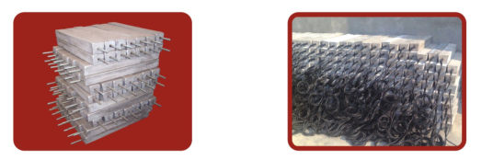
镁合金牺牲阳极 焊接式阳极
Magnesium alloy sacrificial anode Welded plate

填包料
Fill in the package material

■主要用途：改善阳极工作环境，降低阳极接地电阻，增加阳极输出电流，有利于阳极产物的溶解，减少不必要的阳极极化。
Main purpose：Improve anode working environment, reduce anode grounding resistance, increase the anode output current, is beneficial to the dissolution of anode product, reduce unnecessary anodic polarization.

填包料配方表
Complete package material list
阳极类型  The anode type | 填包料配方，重量%  Fill in package material ，The weight of the % |  |  |  | 适用条件  Suitable conditions
阳极类型  The anode type | 石膏粉（CaSo₄.2H₂O)  Gypsum powder | 工业硫酸钠  Industrial sodium sulfate | 工业硫酸镁  Industrial magnesium sulfate | 膨润土  bentonite | 适用条件  Suitable conditions
镁合金牺牲阳极  Magnesium alloy sacrificial anode | 50 | 0 | 0 | 50 | ≤20Ω.m
镁合金牺牲阳极  Magnesium alloy sacrificial anode | 75 | 5 | 0 | 20 | ≥20Ω.m
锌合金牺牲阳极  Zinc alloy sacrificial anode | 50 | 5 | 0 | 45 | ≤20Ω.m
锌合金牺牲阳极  Zinc alloy sacrificial anode | 75 | 5 | 0 | 20 | ≥20Ω.m
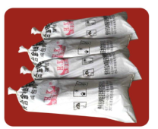
填包料
Fill in the package material

镁带
Magnesium ribbon
■ 主要用途：用于高电阻率环境，套管内管道的保护，管道临时阴极保护、储罐及管网的保护、防强电干扰的接地栅。土壤条件为电阻率50Ω·m， 淡水条件为电阻率50Ω·m
Main purpose：For high resistivity environment, the protection of the casing pipe, the pipe temporary cathodic protection, the protection of storage tanks and pipe network, against heavy current interference of grounding grid. Soil conditions for resistivity 50 Ω m., fresh water conditions for resistivity Ω 50 m
■ 执行标准Execution standard：GB/T 17731-2009

化学成份 Chemical composition
牌号 brand | Al | Zn | Mn | Fe | Ni | Cu | Si | Mg
Mg-Mn | ＜0.010 | - | 0.5-1.30 | ＜0.03 | ＜0.001 | ＜0.02 | - | 余量 allowance
Mg | ＜0.010 | ＜0.010 | ＜0.030 | ＜0.002 | ＜0.001 | ＜0.001 | ＜0.010 | ＞99.95

型号规格 specifications
序号  The serial number | 规格 specifications |  |  | 铁芯直径（mm）  Core diameter | 重量（kg/m）  The weight of the | 牌号brand
序号  The serial number | A （mm） | B（mm） | C（m） | 铁芯直径（mm）  Core diameter | 重量（kg/m）  The weight of the | 牌号brand
1 | 19 | 9.5 | 305 | 3.4 | 0.395 | Mg-Mn
2 | 19 | 9.5 | 305 | 3.4 | 0.357 | Mg
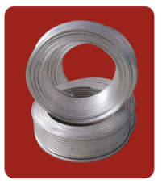
镁带状阳极
Magnesium ribbon anode

铝-锌-铟系合金牺牲阳极
Aluminum and zinc, indium alloy sacrificial anode
■ 主要用途：铝-锌-铟系合金牺牲阳极适于海水介质中的船舶、机械设备、压载水舱、储罐内壁、滨海设施、海底管道、码头钢桩、海洋平台、电缆等设施金属防腐蚀的阴极保护。
Main purpose：Aluminum - zinc, indium alloy sacrificial anode is suitable for seawater medium ships, machinery and equipment, water ballast tank, storage tank wall, littoral facilities, submarine pipeline, wharf steel pile, offshore platform, cables and other facilities metal anticorrosion cathode protection.
■ 执行标准Execution standard：GB/T 4948-2002

化学成份（%） Chemical composition
合金种类  Types of alloy | Zn | In | Cd | Sn | Mg | Si | Ti | 杂质，不大于  Impurities, no greater than |  |  | Al
 |  |  |  |  |  |  |  | Si | Fe | Cu | Al
Al-Zn-In-Cd  A11 | 2.5-4.5 | 0.018-0.050 | 0.005-0.020 | — | — | — | — | 0.10 | 0.15 | 0.01 | 余量allowance
Al-Zn-In -Sn  A12 | 2.2-5.2 | 0.020-0.045 | — | 0.018-0.035 | — | — | — | 0.10 | 0.15 | 0.01 | 余量allowance
Al-Zn-In -Si  A13 | 5.5-7.0 | 0.025-0.035 | — | — | — | 0.10  -0.15 | — | 0.10 | 0.15 | 0.01 | 余量allowance
Al-Zn-In -Sn-Mg  A14 | 2.5-4.0 | 0.020-0.050 | — | 0.025-0.075 | 0.50-1.00 | — | — | 0.10 | 0.15 | 0.01 | 余量allowance
Al-Zn-In -Mg-Ti  A21 | 4.0-7.0 | 0.020-0.050 | — | — | 0.50-1.50 | — | 0.01-0.08 | 0.10 | 0.15 | 0.01 | 余量allowance

电化学性能 The electrochemical properties
性能 performance  种类  species 指标  indicators | 开路电位  -V(SCE)  The open circuit potential | 工作电位  -V(SCE)  Work potential | 实际电容量  Ah/kg  The actual capacitance | 电流效率  %  Current efficiency | 溶解状况  soluble
1型 普通铝合金牺牲阳极  1Type ordinary aluminum alloy sacrificial anode | 1.10-1.18 | 1.05-1.12 | ≥2400 | ≥85 | 产物容易脱落,表面溶解均匀  Product easy to fall off, the surface dissolved evenly
2型 高效铝合金牺牲阳极  2 Type Efficient aluminum alloy sacrificial anode | 1.10-1.18 | 1.05-1.12 | ≥2600 | ≥90
注：阳极材料 A11、A12、A13、A14为 1型，A21为2型
Note：Anode material A11、A12、A13、A14 for 1Type，A21 for 2Type

船体常用牺牲阳极型号规格
Hull sacrificial anode is commonly used specifications
型号Model | 规格 Specification | 重量kg  Weight
型号Model | 长×宽×高mm L×W×H mm | 重量kg  Weight
AH-1 | 800×140×60 单铁脚 Single iron feet | 17.0
AH-2 | 800×140×50 单铁脚 Single iron feet | 15.0
AH-3 | 800×140×40 单铁脚 Single iron feet | 12.0
AH-4 | 600×120×50 单铁脚 Single iron feet | 10.0
AH-5 | 400×120×50 单铁脚 Single iron feet | 6.5
AH-6 | 500×100×40 单铁脚 Single iron feet | 5.5
AH-7 | 400×100×40 单铁脚 Single iron feet | 4.5
AH-8 | 300×100×40 单铁脚 Single iron feet | 3.5
AH-9 | 250×100×40 单铁脚 Single iron feet | 2.5
AH-10 | 180×70×35 单铁脚 Single iron feet | 1.2
AH-11 | 300×150×50 双铁脚 Double iron feet | 5.8
AH-12 | 300×150×40 双铁脚 Double iron feet | 4.6
AH-13 | 300×150×50 螺栓式 Bolt type | 5.8
AH-14 | 300×150×40 螺栓式 Bolt type | 4.8
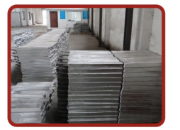
船用铝合金牺牲阳极
Marine aluminium alloy sacrificial anode

港工设施，海洋工程设施常用牺牲阳极型号规格
Port facilities, ocean engineering facilities sacrificial anode is commonly used specifications
型号 Model | 规格 Specification | 重量kg Weight
型号 Model | 长×（上底+下底）×高mm  L×（On the bottom +The bottom）×h mm | 重量kg Weight
AI-1 | 2300×（220+240）×230 | 310.0
AI-2 | 1600×（200+210）×220 | 190.0
AI-3 | 1500×（170+200）×180 | 130.0
AI-4 | 900×（150+170）×160 | 58.0
AI-5 | 1500×（148+178）×170 | 120.0
AI-6 | 850×（180+220）×180 | 85.0
AI-7 | 800×（200+280）×150 | 80.0
AI-8 | 700×（160+220）×180 | 72.5
AI-9 | 1250×（115+135）×130 | 56.0
AI-10 | 1000×（115+135）×130 | 46.0
AI-11 | 750×（115+135）×130 | 35.0
AI-12 | 500×（115+135）×130 | 23.0

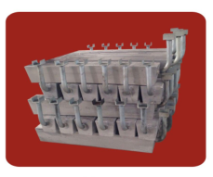
海洋工程用铝合金牺牲阳极
Aluminum alloy sacrificial anode used in ocean engineering

压载水舱常用牺牲阳极型号规格
Sacrificial anode specifications commonly used water ballast tank

型号 Model | 规格 Specification | 重量kg Weight
型号 Model | 长×（上底+下底）×高mm  L×（On the bottom +The bottom）×h mm | 重量kg Weight
AT-1 | 500×（115+135）×130 | 23.0
AT-2 | 1500×（65+75）×70 | 21.5
AT-3 | 500×（110+130）×120 | 20.0
AT-4 | 1000×（58.5+78.5）×68 | 13.2
AT-5 | 800×（56+74）×65 | 10.0
AT-6 | 1150×（48+54）×51 | 9.0
AT-7 | 250×（80+100）×85 | 5.0
AT-8 | 200×（70+90）×70 | 3.0

储管内常用牺牲阳极型号规格
Storage tube sacrificial anode is commonly used specifications
型号 Model | 规格Specification | 重量kg Weight
型号 Model | 长×（上底+下底）×高mm  L×（On the bottom +The bottom）×h mm | 重量kg Weight
AC-1 | 750×（115+135）×130 | 35.0
AC-2 | 500×（115+135）×130 | 23.0
AC-3 | 500×（105+135）×100 | 16.0
AC-4 | 300×（105+135）×100 | 10.0

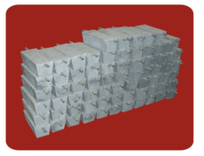
储罐用牺牲阳极
The storage tank with a sacrificial anode

海水冷却水系统常用长条形牺牲阳极型号规格
Elongated sacrificial anode specifications commonly used water cooling water system

型号 Model | 规格 Specification | 重量kg Weight
型号 Model | 长×（上底+下底）×高mm  L×（On the bottom +The bottom）×H mm | 重量kg Weight
AE-1 | 1200×（200+280）×150 | 120.0
AE-2 | 800×（200+280）×150 | 80.0
AE-3 | 1000×（115+135）×130 | 46.0
AE-4 | 500×（115+135）×130 | 23.0
AE-5 | 1000×（80+100）×80 | 20.0
AE-6 | 500×（105+135）×100 | 16.0
AE-7 | 500×（80+100）×80 | 10.0
AE-8 | 400×（110+120）×50 | 7.0
AE-9 | 300×（140+160）×40 | 5.0
AE-10 | 200×（90+110）×40 | 3.0

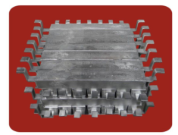
铝合金牺牲阳极
Aluminum alloy sacrificial anode

海水冷却水系统常用圆盘状牺牲阳极型号规格
Seawater cooling water system commonly used disc sacrificial anode specifications

型号Model | 规格 Specification | 重量kg Weight
型号Model | 直径×高 mm Diameter×High mm | 重量kg Weight
AE-11 | 300×60 | 11.5
AE-12 | 360×40 | 9.0
AE-13 | 300×40 | 7.5
AE-14 | 200×50 | 4.0
AE-15 | 180×50 | 3.5
AE-16 | 120×100 | 2.5

常用镯式铝合金阳极规格
commonly used bracelet type aluminum alloy anode specifications

规格 Specification | 重量Kg  Weight | 铁芯规格mm  Core specification
内径×宽度×厚度×间隙mm  inner diameter ×width×thickness×clearance mm | 重量Kg  Weight | 铁芯规格mm  Core specification
Φ1020×200×35×51 | 68 | 5×50
Φ819×60×30×51 | 13 | 5×25
Φ624×80×30×51 | 17 | 5×50
Φ513×100×30×51 | 17 | 5×50
Φ487×200×45×51 | 41 | 5×50
Φ470×480×25×51 | 50 | 5×50
Φ436×480×38×51 | 70 | 5×50
Φ420×413×45×51 | 69 | 5×50
Φ385×150×59×51 | 32 | 5×50
Φ335×505×38×51 | 56 | 5×50
Φ280×250×45×51 | 29 | 5×50
Φ252×250×45×51 | 26 | 5×50
锌-铝-镉合金牺牲阳极
zinc - aluminum - cadmium alloy sacrificial anode

■ 主要用途：锌-铝-镉合金牺牲阳极适用于海水、淡海水介质中的船舶、机械设备、海洋工程和海港设施以及低电阻率土壤中的管道、电缆等设施金属防腐蚀的阴极保护。
Main purpose：zinc - aluminum - cadmium alloy sacrificial anode used in seawater, brackish water medium ship, mechanical equipment, Marine engineering and port facilities, and low resistivity metal anti-corrosion pipes, cables and other facilities in the soil of cathodic protection.
■ 执行标准Execution standard： GB/T4950-2002

化学成份（%）Chemical composition
化学元素  chemical elements | Al | Cd | 杂质元素、不大于 impurity elements, not greater than |  |  |  | Zn
化学元素  chemical elements | Al | Cd | Fe | Cu | Pb | Si | Zn
含量  content | 0.3-0.6 | 0.05-0.12 | 0.005 | 0.005 | 0.006 | 0.125 | 余量  allowance

电化学性能  electrochemical properties | 开路电位  -V(SCE)  open circuit potential | 工作电位  -V(SCE) | 实际电容量  Ah/kg  Work potential | 电流效率%  Current efficiency | 消耗率  Kg.（A.a）⁻¹  ^{Consumption rate} | 溶解状况  soluble
海水中  In the seawater | -1.09～-1.05 | -1.05～-1.00 | ≥780 | ≥95 | ≤11.23 | 产物容易脱落,表面溶解均匀  Product easy to fall off, the surface dissolved evenly
土壤中  In the soil | ≤-1.05 | ≤-1.03 | ≥530 | ≥65 | ≤17.25
电化学性能 electrochemical properties

船体常用牺牲阳极型号规格
Hull sacrificial anode is commonly used specifications

型号 Model | 规格 Specification | 重量kg Weight
型号 Model | 长×宽×高mm (L×W×H)mm | 重量kg Weight
ZH-1 | 800×140×60 单铁脚 Single iron feet | 47.0
ZH-2 | 800×140×50 单铁脚 Single iron feet | 39.0
ZH-3 | 800×140×40 单铁脚 Single iron feet | 31.0
ZH-4 | 600×120×50 单铁脚 Single iron feet | 25.0
ZH-5 | 400×120×50 单铁脚 Single iron feet | 16.0
ZH-6 | 500×100×40 单铁脚 Single iron feet | 13.6
ZH-7 | 400×100×40 单铁脚 Single iron feet | 11.0
ZH-8 | 300×100×40 单铁脚 Single iron feet | 7.5
ZH-9 | 250×100×40 单铁脚 Single iron feet | 6.5
ZH-10 | 180×70×40 单铁脚 Single iron feet | 3.5
ZH-11 | 300×150×50 双铁脚 Double iron feet | 15.4
ZH-12 | 300×150×40 双铁脚 Double iron feet | 11.5
ZH-13 | 300×150×50 螺栓式 Bolt type | 12.0
ZH-14 | 300×150×40 螺栓式 Bolt type | 9.0

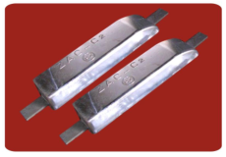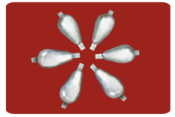
锌合金牺牲阳极 水滴状锌合金牺牲阳极
Zinc alloy sacrificial anode teardrop-shaped zinc alloy sacrificial anode

压载水舱用牺牲阳极型号规格
Ballast tank with a sacrificial anode specifications

型号 Model | 规格 Specification | 重量kg Weight | 压载水舱用牺牲阳极结构图  Ballast tank with a sacrificial anode structure
型号 Model | 长×（上底+下底）×高mm  L×（On the bottom +The bottom）×H mm | 重量kg Weight
ZT-1 | 500×（115+135）×130 | 56.0 | 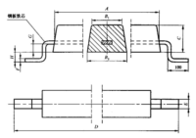
ZT-2 | 1500×（65+75）×70 | 50.0
ZT-3 | 500×（110+130）×120 | 50.0
ZT-4 | 1000×（58.5+78.5）×68 | 33.0
ZT-5 | 800×（56+74）×65 | 25.0
ZT-6 | 1150×（48+54）×51 | 20.0
ZT-7 | 250×（80+100）×85 | 13.0
ZT-8 | 200×（70+90）×70 | 7.5

港工和海洋工程设施用牺牲阳极型号规格
Port and Marine engineering facilities in sacrificial anode specifications

型号 Model | 规格 Specification | 重量kg  Weight | 港工和海洋工程用牺牲阳极结构图  Port and sacrificial anode used in ocean engineering structure
型号 Model | 长×（上底+下底）×高mm  L×（On the bottom +The bottom）×H mm | 重量kg  Weight | 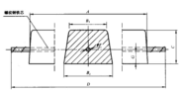
ZI-1 | 1000×（115+135）×130 | 115.0
ZI-2 | 750×（115+135）×130 | 85.0
ZI-3 | 500×（115+135）×130 | 56.0
ZI-4 | 500×（105+135）×100 | 40.0

海水冷却水系统用长条形牺牲阳极型号规格
Seawater cooling water system with elongated sacrificial anode specifications

型号 Model | 规格 Specification | 重量kg  Weight | 海水冷却水系统用圆盘状牺牲阳极结构图  Seawater cooling water system with disc sacrificial anode structure
型号 Model | 直径×高mm Diameter×High mm | 重量kg  Weight
ZE-8 | 300×60 | 30.0 | 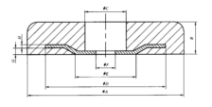
ZE-9 | 360×40 | 28.5
ZE-10 | 300×40 | 20.0
ZE-11 | 200×50 | 10.5
ZE-12 | 180×50 | 8.5
ZE-13 | 120×100 | 7.5
型号  Model | 规格 Specification | 重量kg Weight | 港工设施和海水冷却水系统用牺牲阳极结构图  Port facilities and sea water cooling water system in sacrificial anode structure
型号  Model | 长×（上底+下底）×高mm  L×（On the bottom +The bottom）×H mm | 重量kg Weight
ZE-1 | 500×（115+135）×130 | 56.0 | 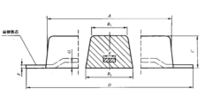
ZE-2 | 1000×（80+100）×80 | 50.0
ZE-3 | 500×（105+135）×100 | 40.0
ZE-4 | 500×（80+100）×80 | 25.0
ZE-5 | 400×（110+120）×50 | 16.0
ZE-6 | 300×（140+160）×40 | 12.5
ZE-7 | 200×（90+110）×40 | 5.5

海水冷却水系统用圆盘状牺牲阳极型号规格
Seawater cooling water system with disc sacrificial anode specifications

储罐内用牺牲阳极型号规格
storage tank with a sacrificial anode specifications

型号  Model | 规格 Specification | 重量kg Weight | 储罐内用牺牲阳极结构图  storage tank with a sacrificial anode structure
型号  Model | 长×（上底+下底）×高 mm  L×（On the bottom +The bottom）×H mm | 重量kg Weight | 储罐内用牺牲阳极结构图  storage tank with a sacrificial anode structure
ZC-1 | 750×（115+135）×130 | 85.0 | 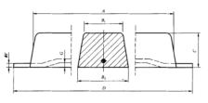
ZC-2 | 500×（115+135）×130 | 56.0
ZC-3 | 500×（105+135）×100 | 40.0
ZC-4 | 300×（105+135）×100 | 25.0

埋地管线用牺牲阳极型号规格
型号 Model | 规格 Specification | 重量kg Weight | 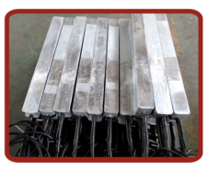  埋地管线用锌合金牺牲阳极  buried pipeline with zinc alloy sacrificial anode
型号 Model | 长×（上底+下底）×高mm  L×（On the bottom +The bottom）×H mm | 重量kg Weight
ZP-1 | 1000×（78+88）×85 | 50.0
ZP-2 | 1000×（65+75）×65 | 33.0
ZP-3 | 800×（60+80）×65 | 25.0
ZP-4 | 800×（55+64）×60 | 22.0
ZP-5 | 650×（58+64）×60 | 18.0
ZP-6 | 550×（58+64）×60 | 15.0
ZP-7 | 600×（52+56）×54 | 12.5
ZP-8 | 600×（40+48）×45 | 9.0
buried pipeline in sacrificial anode model specifications

锌 带
Zinc strip
■ 主要用途：锌带阳极广泛应用于石油、化工、海洋工程、交通、电力、市政工程等领域，通常用于电阻率低于2000Ω.cm的介质；如果被保护的钢结构有很好的涂层或在土壤潮湿情况下，锌带阳极可用于高于2000Ω.cm的介质。为了提高锌带阳极的使用性能，可采用填充料，标准的填充材料是硫酸钙加膨润土，用以吸收和保持水分，降低电阻。
Main purpose：Zinc anode is widely used in petroleum, chemical, Marine engineering, transportation, electricity, municipal engineering and other fields, is typically used for resistivity is lower than 2000 Ω. Cm medium; If the protection of steel structure has good coating or under the condition of soil moisture, zinc anode can be used to bring over 2000 Ω. Cm medium. In order to improve the use of zinc strip anode performance, filling material can be used, the standard of filling material is calcium sulfate added bentonite, to absorb and retain water, reduce the resistance.
■ 执行标准 Execution standard： ASTM B 843-1995 SY/T0019-1997
化学成份(%) Chemical composition
种类  kind | Al | Cd | Fe  (Max) | Pb  (Max) | Cu  (Max) | Zn
Ⅰ | 0.1-0.5 | 0.02-0.07 | 0.005 | 0.006 | 0.005 | 余量 allowance
Ⅱ | 0.005(Max) | 0.003(Max) | 0.0014 | 0.003 | 0.002 | 余量 allowance
高纯锌 High purity zinc | 0.003(Max) | 0.002(Max) | 0.001 | 0.003 | 0.001 | 余量 allowance

规格型号 specifications
规格  specifications | 型号  model | 尺 寸 size |  |  | 单重(g/cm)  Single heavy
规格  specifications | 型号  model | A(mm) | B(mm) | C(m) | 单重(g/cm)  Single heavy
ZR-1 | 特大(A) | 25.4 | 31.75 | 30.5 | 35.72
ZR-2 | 大(B) | 15.88 | 22.23 | 61 | 17.82
ZR-3 | 标准(C) | 12.7 | 14.28 | 152 | 8.93
ZR-4 | 小(D) | 8.73 | 11.91 | 305 | 3.72

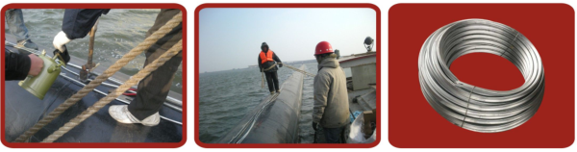
锌带状阳极 Zinc ribbon anode
恒电位仪
constant potential rectifier
■ 主要用途: 恒电位仪是外加电流阴极保护系统中向被保护金属构筑物表面提供直流的关键设备.
Main application: rectifers impressed current cathodic protection system to be protected metal surface of structures to provide dc key equipment

常用恒电位仪型号规格 Commonly used the potentiostat specifications
型号  Model | 输入电压  input voltage | 输出电流/输出电压  output current /input voltage | 备注  note
KHL－1 | 220V/50Hz | 0～10A/0～20V | 可控硅式。额定输出电流、电压可根据用户要求制造。  SCR type.Rated output current and voltage can be according to user requirements.
KHL－2 | 220V/50Hz | 0～20A/0～30V
KHL－3 | 220V/50Hz | 0～30A/0～50V
KHL－4 | 220V/50Hz | 0～30A/0～75V
KHL－5 | 380V/50Hz | 0～50A/0～50V
KHL－6 | 380V/50Hz | 0～75A/0～75V
KHL－7 | 380V/50Hz | 0～75A/0～100V
KHL－8 | 380V/50Hz | 0～100A/0～100V
KHL－9 | 380V/50Hz | 0～120A/0～120V
KHL－10 | 380V/50Hz | 0～150A/0～150V
CBH－1 | 220V/50Hz | 3～10A/10～50V | 磁饱和式。额定输出电流、电压可根据用户要求制造。  Magnetic saturation type.Rated output current and voltage can be according to user requirements.
CBH－2 | 220V/50Hz | 3～20A/10～50V
CBH－3 | 220V/50Hz | 3～30A/10～50V
CBH－4 | 380V/50Hz | 1～50A/10～50V
CBH－5 | 380V/50Hz | 1～75A/10～50V
CBH－6 | 380V/50Hz | 1～75A/10～75V
CBH－7 | 380V/50Hz | 1～100A/10～100V
CBH－8 | 380V/50Hz | 1～100A/10～150V
DJH | 380V/50Hz | 0～300A/0～40V | 大功率晶体管式。额定输出电流、电压可根据用户要求制造。  High power transistor type.Rated output current and voltage can be according to user requirements.
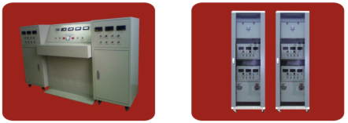
恒电位仪 constant potential rectifier 恒电位仪 constant potential rectifier
高硅铸铁阳极
High silicon cast iron anodes
■ 执行标准Execution standard: SYJ36—89 SY/T0036-2000
■ 主要用途: 高硅铸铁阳极广泛应用于海上石油钻井平台、地下管道、地下电缆等设施的外加电流的阴极保护。
Main application: High silicon cast iron anodes are widely used in maritime oil drilling platform, underground pipelines, underground cable and other facilities of the impressed current cathodic protection.

化学成份（%） Chemical composition
品名  Of the goods | 化学元素% The chemical elements |  |  |  |  | 杂质含量% Impurity content
品名  Of the goods | Si | Cr | Mn | C | Fe | P | S
高硅铸铁  High silicon cast iron | 14-16 | — | 0.6-0.8 | 0.8-1.05 | 余量  allowance | ≤0.25 | ≤0.1
含铬硅铁  Chromium ferrosilicon | 14-16 | 4.0-4.5 | 0.6-0.8 | 0.8-1.05 | 余量  allowance | ≤0.25 | ≤0.1

规格尺寸 size
型号 model | 规格mm specifications | 重量kg  weight | 阳极附带电缆 anode with cable
型号 model | 规格mm specifications | 重量kg  weight | 截面mm Cross section | 长度mm length
HKG-1 | Φ50×1500 | 22 | 25 | 1000
HKG -2 | Φ75×1200 | 40 | 25 | 1000
HKG -3 | Φ75×1500 | 50 | 25 | 1000
HKG -4 | Φ100×1500 | 90 | 25 | 1000
外形尺寸及规格型号可根据用户需求而生产
Overall dimensions and specifications according to user requirements and production
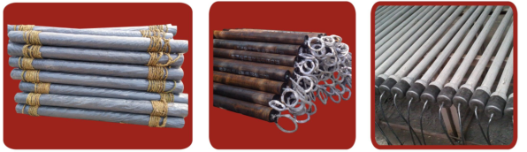
高硅铸铁阳极 高硅铸铁阳极 高硅铸铁阳极
High silicon cast iron anodes High silicon cast iron anodes High silicon cast iron anodes

深井阳极/浅埋阳极
Deep well anode/shallow buried anode
■ 主要用途: 深井阳极适用于大型长输管线、城市管网、水电工程、表层土壤电阻率高的地区埋地金属构筑物的阴极保护。是长输管线、城市管网、区域性保护的主要技术之一。
Main use: deep well anode is suitable for large long distance pipeline, city pipeline, water and electricity engineering, surface soil resistivity of the buried cathodic protection of metallic structures. Is long distance pipeline, city pipeline network, regional protection of one of the main technology.
★ 深井阳极是指阳极体顶部距地面≥15m的阳极地床，是相对浅埋阳极而言。
Deep well anode is the top 15 m away from the ground or anode anode ground bed, is a relatively shallow buried anode.
■ 结构特点Structural characteristics of ：
★ 深井阳极系统由深井阳极体、深井阳极、内导气装置、填充料、电缆、护井装置等结构组成。
Deep well anode system by deep well anode body, deep well anode, guide gas equipment, filling material, such as cable, protector device structure.
★ 深井阳极根据要求可采用贵金属氧化物阳极、高硅铸铁阳极。
Deep well anode can be used according to the precious metal oxide anode and duriron anode.

型号规格 specifications
型 号  model | 贵金属氧化物阳极mm  Precious metal oxide anodes | 高硅铸铁阳极mm  High silicon cast iron anodes | 阳极体尺寸mm  The anode body size | 内装阳极数量（支）  Within the anode quantity （branch） | 阳极类型  anode type
HKSJ-1 | ￠25×1000 | ￠75×1500 | ￠273×6000 | 3 | 深井阳极 Deep well anode
HKSJ-2 | ￠25×1000 | ￠75×1500 | ￠219×6000 | 3 | 深井阳极 Deep well anode
HKQM-3 | ￠25×1000 | ￠75×1500 | ￠273×2000 | 1 | 浅埋阳极 shallow buried anode
HKQM-4 | ￠25×1000 | ￠75×1500 | ￠219×2000 | 1 | 浅埋阳极 shallow buried anode
注：高硅铸铁还可使用￠100×1500mm；￠50×1500mm，表中数据仅供参考，还可根据客户需求设计、生产。
Note: high silicon cast iron can also use ￠100 x 1500 mm; ￠50 * 1500 mm, and the data in the table is for reference only, can also according to customer demand design, production.
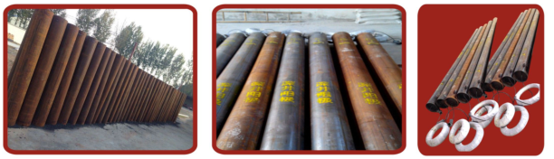
预包装高硅铸铁阳极 深井阳极 深井阳极
Pre-packaged duriron anode Deep well anode Deep well anode
贵金属氧化物管状阳极
Precious metal oxide tubular anode
■ 主要用途：是在钛基材上覆盖一层具有电催化活性的金属氧化物而构成，氧化物涂层极化小并且消耗率极低，通过调整氧化物层的成分，可以使其适于不同的环境，如海水、淡水、土壤介质中，由于贵金属氧化物阳极具有其它阳极所不具备的优点，它已成为目前最为理想和最有前途的辅助阳极材料。
Main application: it is in the titanium substrate was covered a layer of electric catalytic activity of metal oxide, constitute, the oxide coating polarization small and consumption rate is extremely low, by adjusting the composition of the oxide layer, can make it suitable for different environments, such as sea water, fresh water, the soil medium, because of the precious metal oxide anode has the advantages of other anode don't have it has become the most ideal and most promising auxiliary anode material.

贵金属氧化物管状阳极规格型号
Precious metal oxide tubular anode specifications
阳极名称 name of the anode | 规格尺寸 size | 排流量（A）  Line of traffic | 使用寿命（年）  service life （years）
贵金属氧化物管状阳极  Precious metal oxide tubular anode | φ25×1000 | 8.0 | 20
贵金属氧化物管状阳极  Precious metal oxide tubular anode | φ25×700 | 5.0 | 20

MMO带规格型号 MMO with specifications
型号 model | 规格 specifications | 每卷净重 net weight per roll | 寿命life
MMO带 MMO with | 6.35±0.30 mm×0.635±0.07mm×152m±1m | 2.8㎏ | 50年  fifty years
钛导电带规格型号
Titanium conductor with specifications
型号 model | CF-T-C
材料 material | Titanium
级别 level | ASTM B265 Gr1orGr2
规格 specifications | 12.7±0.30 mm×0.9±0.09mm×152（76）m±1m
每卷净重 net weight per roll | 7.8㎏（3.9㎏）

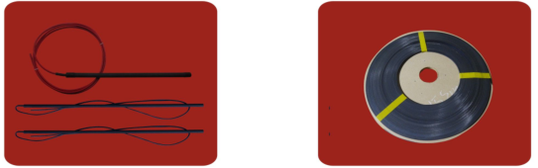
贵金属氧化物阳极 Precious metal oxide anodes 钛导电带 Titanium conduction band
柔性阳极
Flexible anode
（1）MMO柔性阳极
柔性阳极由 MMO 阳极线、焦碳回填料、纤维织物包覆套（填料袋）和耐磨编织网组成。混合金属氧化物/铜导体电缆为内芯，外覆炭粉回填料于预包装好的柔软的护套中。
产品特性：综合了MMO阳极的发生电流大和铜芯电缆的导电性能佳的优点。由于发生电流大，接地电阻小，可以在远离阳极结构的地方埋设。特别适用于高阻地区或涂层破损的管道阴极保护，也可用于大型储罐罐底板外加电流阴极保护。由于阳极本身含用焦碳分，因此现场安装时不需要加填料，安装方便快捷。
Flexible MMO anode
Flexible anode by the MMO anode line, coke packing, fabric coated (packing bag) and wear-resisting of woven mesh. Mixed metal oxide/copper conductor cable for, the inner core coated with carbon powder packing back in pre-packaged good soft sheath.
Product features: a combination of the happening of the MMO anode current and the advantages of the conductive properties of copper core cable. Because of large current, grounding resistance is small, can be away from the anode structure buried. Particularly suitable for high resistance area or pipeline cathodic protection of coating damage, can also be used in large storage tank bottom impressed current cathodic protection. Due to the anode containing itself with coke, so don't need to add filler when installation, convenient and quick installation.
（2）导电聚合物型柔性阳极是以导电聚合物为基材制作的均匀连续结构辅助阳极。阳极主体是由铜导线、导电聚合物护套组成的一体化均匀连续结构。其外层结构是由焦碳包覆层、耐酸碱织层、耐磨编织网组成。
产品特性：导电聚合物柔性阳极起关键作用的是导电聚合物为辅材的中心铜导体。这种结构不但可以防止铜芯受化学腐蚀，并可以保证电流长距离传输。同时，又有小量的阴极保护电流连续不断的滴流、扩散于导电聚合物辅层中，使全长的辅层都有电流渗透。可以安装在最接近被保护的构件附近，解决了屏蔽和干扰问题；
Conductive polymer type flexible anode conductive polymers as base material made of homogeneous continuous structure auxiliary anode. Anode body is composed of copper wires, conductive polymer sheath integration homogeneous continuous structure. The outer structure is by the coke layer, wear-resisting, acid and alkali resistant woven layer of woven mesh.
Product features: flexible anode conductive polymers play a key role is the center of the conductive polymers as auxiliary material of copper conductor. This structure can not only prevent the copper from chemical corrosion, and can guarantee the current long-distance transmission. At the same time, and there was a small amount of cathodic protection current continuous drip, diffusion in conductive polymers and auxiliary layers, make full-length auxiliary layer has a current penetration. Can be installed near the closest to a protected member, solved the problems of blocking and interference;
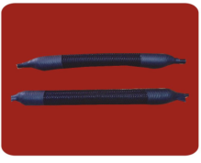 柔性阳极 Flexible anode

固态去耦合器
Solid state to the coupler
■ 主要用途：能有效隔离阴极保护直流电流，同时抑制直流杂散电流反向流入管道，并能排除正常阴极保护电压外的直流杂散电流，对管道上耦合的交流电流具有低阻抗全导通特性，能有效降低感应的管道交流干扰电压。
Main use: isolated dc current cathodic protection effectively, suppress dc stray current reverse flow into the pipe at the same time, and can eliminate normal cathodic protection outside dc stray current and voltage on line coupling of alternating current has a low impedance conduction characteristics, pipe communication interference can effectively reduce the induction voltage.

序号  serial number | 项目  project | 技术参数  Technical parameters
1 | 直流启动电压(1mA)  Start the dc voltage | -2.0V/+2.0V
2 | 交直流排流电流额定值  Rated value of AC / DC current | 50A
3 | 标称放电电流  Nominal discharge current | 100kA（8/20μs）
4 | 最大放电电流  The maximum discharge current | 200kA（8/20μs）
5 | 泄漏电流  Leakage current | ≤10μA
6 | 交流阻抗  Ac impedance | <0.01Ω
7 | 冲击导通电压  Impact conduction voltage | ≤2200V（1.2/50μs）
8 | 故障电流  Fault current | （AC-rms/工频 Power frequency  /30周波 frequency ）≥3500A
9 | 响应时间  The response time | ≤1ns
10 | 工作温度  Working temperature | -45℃～+60℃
■安装说明 Installation instructions
- 将产品一端连接在管道上，一端连接在接地网上，接地网的接地电阻值应控制在4欧姆之内。
Connect one end products on the pipe, one end connected to the grounding net, ground net.through earthing resistance value should be controlled within 4 ohms.
- 本产品可采用防爆箱结构，直接安装在防爆环境里。
This product can use explosion-proof box structure, installed directly in the explosion-proof environment.
- 本产品采用密封结构，可安装在潮湿的地方。
This product adopts the sealing structure, can be installed in the wet place.

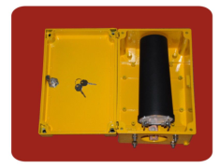
固态去耦合器
Solid state to the coupler

参比电极
Reference electrode
■ 主要用途：用于牺牲阳极保护电位的测量，在外加电流阴极保护系统中，作自动控制的稳定信号源，适用于埋地管道及地下金属构筑物的阴极保护工程。
Main application: used for sacrificial anode protection potential measurement, the impressed current cathodic protection system, automatic control the stability of the signal source, suitable for buried pipeline and metal structure of the cathodic protection of underground engineering.
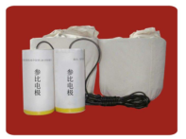
参比电极 Reference electrode
规格型号
specifications
名称 name | 型号  model | 规格mm  specifications | 寿命  life | 适用环境  Apply to the environment
铜/饱和硫酸铜参比电极  Copper/saturated copper sulfate reference electrode | CCT | φ 30×150 | 补充硫酸铜后继续使用  Continue to use after add copper sulfate | 便携式，用于水及土壤中现场测量  Portable, used in water and soil field measurement
 | MCT-｜ | Φ100×230 | ＞5年 | 土壤 soil
 | MCT- ‖ | -- | ＞10年 | 埋地用长寿命电极 Electrode buried with long life
银/氯化银参比电极  The silver/silver chloride reference electrode | CCY-1 | Φ63×300 | 15-20年 | 海水 The sea
银/氯化银参比电极  The silver/silver chloride reference electrode | CCX-‖ | Φ30×150 | 6-8年 | 海水 The sea
银/氯化银参比电极  The silver/silver chloride reference electrode | CCX-Ⅲ | Φ25×130 | 3-5年 | 海水The sea
高纯锌参比电极  High purity zinc reference electrode | CCX-Ⅰ | -- | ＞10年 | 海水、淡海水  The sea 、Brackish water

极化探头
Polarization of the probe
■ 主要用途：是由铜—硫酸铜参比电极和与之围绕的碳钢钢盘及盐桥组成，钢盘通过导线和测试桩与被测管道连接并引入极化。从而使测量通道的电阻压降减至最小并有效地屏蔽了外界电流的干扰，使得在杂散干扰区十分困难的管地电位测量变得简单、平滑、可靠、真实。
Main application: is made up of copper, copper sulfate, reference electrode and the surrounding the composition of carbon steel plate and salt bridge, steel plate through a wire and the test pile and pipe connection being measured and introducing polarization. So that the resistance of the measuring channel to minimize pressure drop and effectively blocked access to the outside world current interference, made in spurious interference very difficult pipe-to-soil potential measurements become simple, smooth, reliable and true.

锌接地电池
Zinc grounding cell
■ 主要用途：锌接地电池是绝缘接头的配套产品，允许瞬时大电流冲击，可为管道绝缘连接提供防雷击和其它高压故障电流保护。与内藏式避雷装置比较，最大的优势是其防护性能可方便地进行检测，因而具有更高的安全可靠性。
Main use: zinc grounding cell is insulation joint product of form a complete set, allow instantaneous large current shock, can provide lightning protection for pipe insulation joint and other high pressure fault current protection. With working "lightning protection device, the biggest advantage is its protective performance can be easily tested, thus has higher safety and reliability.

规格型号
specifications
型号 model | 规格
型号 model | 长×宽×宽（直径×高）mm  L×W×W(D×H)
ZJD-1 | 1000×40×40
ZJD-2 | 1500×40×40
ZJD-3 | Φ40×1000
ZJD-4 | Φ40×1500
ZJD-5 | Φ60×2000

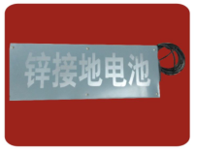
锌接地电池
Zinc grounding cell

铝热焊剂
Aluminum heat flux
■ 主要用途： 用于煤气、石油、天然气化工钢管的阴极保护及电力电缆的焊接。
Main application: used in gas, oil, natural gas chemical industry welding steel pipe of cathodic protection and power cable.

铝热焊剂、铝热焊模具规格型号
Aluminum heat flux, heat welding mold specifications
序号  The serial number | 名 称 name | 规格(克)  specifications  （g ）
1 | 铝热焊剂 Aluminum heat flux | 10
2 | 铝热焊剂Aluminum heat flux | 15
3 | 铝热焊剂Aluminum heat flux | 20
4 | 铝热焊剂Aluminum heat flux | 30
名称 name | 规格specifications | 材质  The material
铝热焊模具  Aluminium heat welding mold | 10 | 石墨  graphite
铝热焊模具  Aluminium heat welding mold | 15 | 石墨graphite
铝热焊模具  Aluminium heat welding mold | 20 | 石墨graphite
铝热焊模具  Aluminium heat welding mold | 30 | 石墨graphite

测试桩
The test of pile
■ 主要用途: 用于阴极保护参数的检测，是管道管理维护中必不可少的装置，按测试功能沿线布设。测试桩可用于管道电位、电流、绝缘性能的检测,也可用于覆盖层检漏及交直流干扰的测试。 注：还可根据客户要求生产不同规格的测试桩。
Main application: used in the detection of cathodic protection parameters, is essential in maintaining pipeline management device, according to the testing function layout along the road. Test pile can be used in the detection of pipeline potential, current, insulation performance, can also be used to cover the leak detection and ac/dc interference test. Note: also can be according to customer request production of different specifications of the test pile.

型号Model | 规格 specifications | 材质  The material
型号Model | 直径×长×壁厚（长×宽×高）mm  D×L×W（L×W×H）mm | 材质  The material
CS-1 | Φ108×3000×4 | 碳钢/玻璃钢  Carbon steel /Glass fiber reinforced plastic
CS-2 | Φ108×2500×4 | 碳钢/玻璃钢  Carbon steel /Glass fiber reinforced plastic
CS-3 | Φ108×2000×4 | 碳钢/玻璃钢  Carbon steel /Glass fiber reinforced plastic
CS-4 | Φ108×1500×4 | 碳钢/玻璃钢  Carbon steel /Glass fiber reinforced plastic
CS-5 | 1600×120×120 | 水泥  cement
CS-3 | 1500×120×120 | 水泥  cement
CS-4 | 1200×120×120 | 水泥  cement

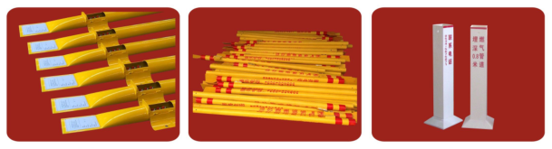
钢制测试桩 玻璃钢测试桩 水泥测试桩
Steel test piles Glass fiber reinforced plastic test pile Cement test pile

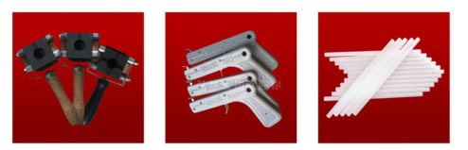
铝热焊模具 点火枪 热熔胶
Aluminium heat welding mold Firing gun Hot melt adhesive
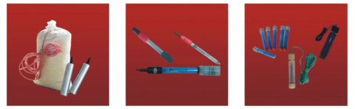
锌参比电极 银氯化银参比电极 便携式参比电极 A portable reference electrode
Zinc reference electrode Silver and silver chloride reference electrode
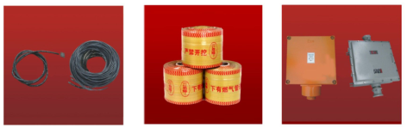
阴极保护电缆线 警示带 防爆接线箱
Cathodic protection cable Warning belt Explosion-proof junction box
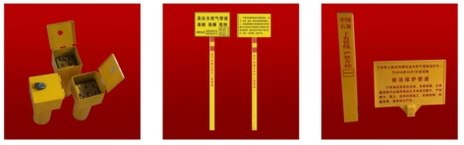
测试桩 警示牌 标志桩
The test of pile Placard Mark pile

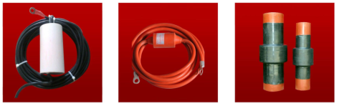
避雷器 电火花间隙 绝缘接头
Surge arrester Spark gap Insulation joint
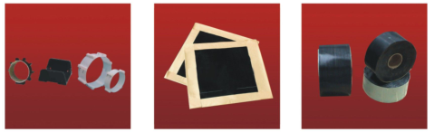
管道支架 补伤片 防腐胶带
Pipe supports Patching piece Anticorrosion tape
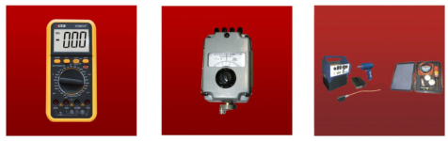
数字万用表 接地电阻测试仪 铜焊机
Digital multimeter Grounding resistance tester Copper welding machine
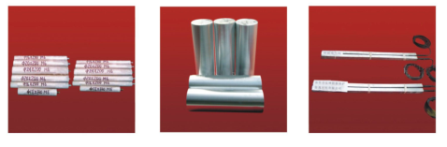
镁阳极棒 半连续镁合金铸棒 锌接地电池
Magnesium anode Semi-continuous casting magnesium alloy rod Zinc grounding cell

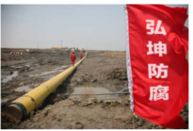
我们是地下管网的“护管使者”，
We are one of the underground pipe network "messenger protection pipe,"
我们为国家百年大计做栋梁之材，
We do useful to our plans in one hundred to the nation,
我们全力以赴夺回腐蚀造成的损失，
We made an all-out effort to regain the loss caused by corrosion,
我们一如既往的坚持创新，
We as always adhere to innovation,
它们建设到哪里，
Where their construction,
哪里就有弘坤的足迹。
There are hong kun's footprint.

图例 legend
已建成天然气管道干线 Has been built main gas pipeline
已建成原油管道干线 Has been built main crude oil pipeline
已建成成品油管道干线 Completed products pipeline trunk line
拟建天然气管道干线 The proposed main gas pipeline
拟建原油管道干线 The main process of crude oil pipeline

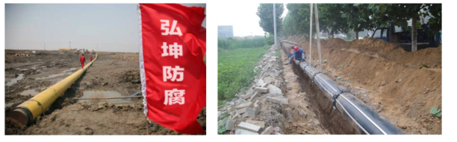
山西省天然气阴极保护工程 新郑机场阴极保护项目
Natural gas cathodic protection project in Shanxi Province Xinzheng airport cathodic protection project
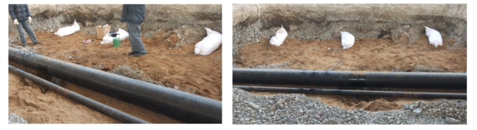
葫芦岛海军基地阴极保护安装
Huludao naval base on cathodic protection installation
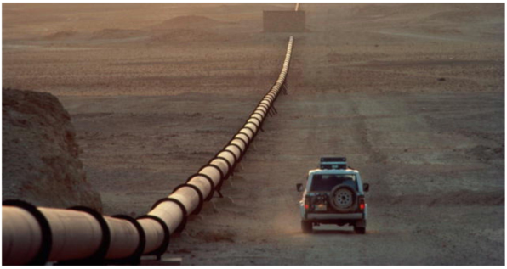
我们参与了西气东输阴极保护建设新疆、江西、河南、浙江、内蒙、山西、广东……
We participated in the construction of west to east gas pipeline cathodic protection in xinjiang, jiangxi, henan, zhejiang, Inner Mongolia, shanxi, guangdong...

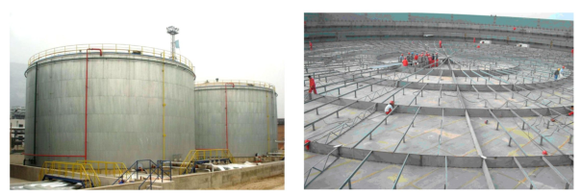
天津港石化仓储阴极保护项目 玉门石油阴极保护安装
Tianjin petrochemical storage and cathodic protection project Yumen oil cathodic protection installation
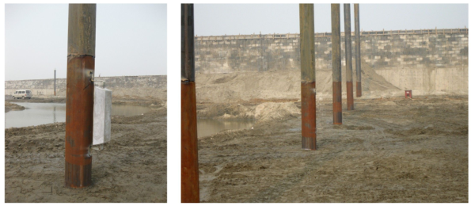
京唐港阴极保护
Jingtang cathodic protection
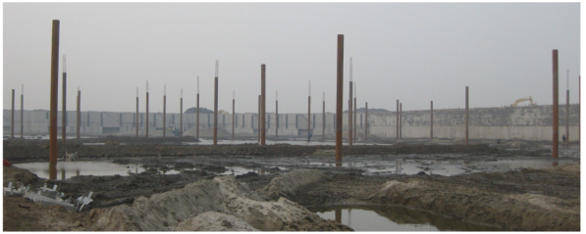
广东液化气、天然气项目——配套码头阴极保护项目
Guangdong liquefied petroleum gas, natural gas project ——Supporting pier cathodic protection project

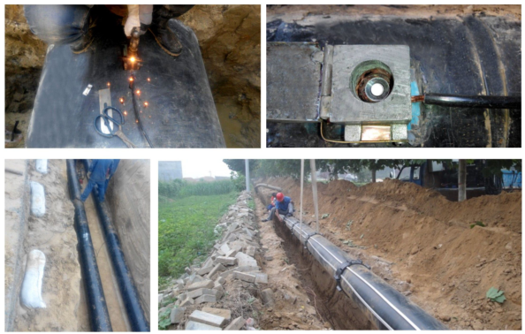
临县煤层气管道——牺牲阳极、锌带安装
Lin County coal-bed gas pipeline——Sacrificial anode, zinc strips

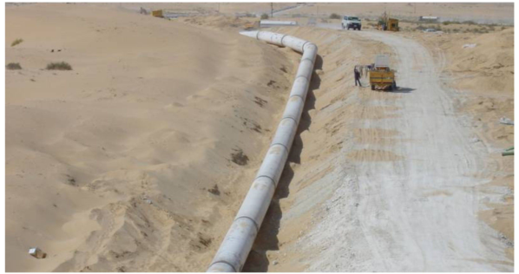
长庆气田—乌海输气管道阴极保护
Changqing gas field— The wuhai pipeline cathodic protection

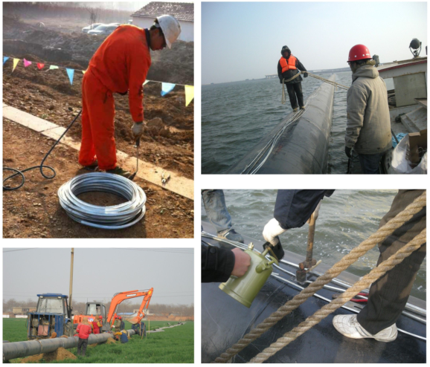
金丽温管线阴极保护——锌带安装
Zone pipeline cathodic protection ——Zinc strips
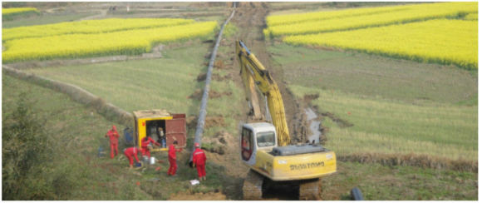
西气东输
West to east gas pipeline

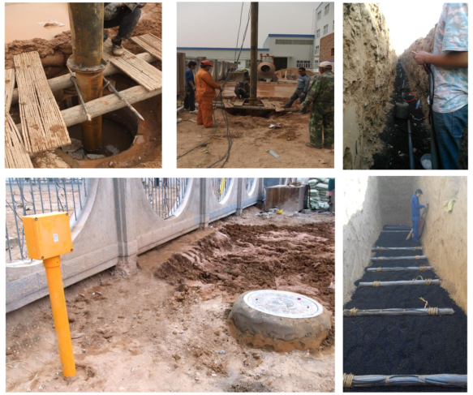巩义昆仑燃气高压管道阴极保护项目——深井阳极安装 中国石油永登油库外加电流项目
Gongyi kunlun gas high-pressure pipeline cathodic protection project ——Deep well anode installation
China's oil and oil depot impressed current project

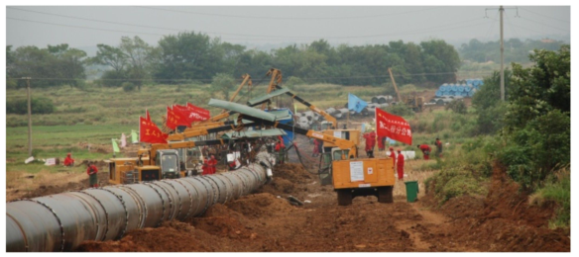
辽西北管道阴极保护工程
Liaoning northwest pipeline cathodic protection engineering

