BH系列高频感应加热设备
BH Series High Frequency Induction Heating Machine
整机特性：
1.采用进口MOSFET及IGBT 固态功率模块和先进的谐振变频技术，高效节能，输出功率大；
2.数字锁相技术，实现频率自动跟踪，极大的优化金属的加热过程，实现高效快速加热，产品优越性得到极大发挥；
3.100%满负载持续率设计，可连续24小时不间断工作，可配红外测温仪，实现温度的自动控制，提高加热质量，简化人工操作；
4.保护功能完善，具有过压、过热、过流、欠水、缺相等多种故障状态保护和显示，提拱更高的可靠性和耐用性，维修率低；
5.加热-保温-冷却三段时间可分别独立调节，获得所需的加热保温过程，在一定程度上有效地控制加热曲线和加热温度，适应批量化、重复性、快速加热的工件。应用于钎焊中时，采用快速加热和保温功能相结合，既实现快速加热，同时又可在焊料熔化时进行保温，使焊料充分铺展；
6.加热功率和保温功率均可调节 ，频率越高加热浓度越浅，频率越低透热性越好；
7.操作简单，设备给出端为安全电压，不会伤及人身安全。
Main Features:
1.Adopted European MOSFET,IGBT solid power module and advanced resonance inverter technology,high efficiency,big output power and energy saving;
2.The digital phase-locked technology achieve frequency trucking automatically,optimization of metal heating process,ensure high efficiency and high speed heating;
3.100% full duty cycle,can work for 24hours continuously.Can control the heating temperature remotely and automatically by extra Infrared Thermometer,improve the heating quality and reduce human operation;
- Perfect protecting functions,include “over-current, over voltage, water shortage, lack of phase and other fault state self-protected and display”,also some other necessary functions which will ensure our heater’s higher reliability and durability;
- The time of three stages:“Heating”,”Maintain Temperature”,”Cooling” can be adjusted separately. Furthermore,the function of adjusting the power of ”Maintain Temperature” independently will be effective to control the heating curve and the heating temperature,suitable for workpiece of mass production,repeatability,rapid heating.when used in brazing,adopt combination of rapid heating and maintain temperature,not only heating fast,also solder spread out fully;
6.Easily operate and the output voltage is safe for operator.
主要技术参数Main Technical Parameters:
型号Model | BH-5A | BH-15A | BH-15AB | BH-25A | BH-25AB | BH-40AB | BH-60AB | BH-80AB | BH-100AB | BH-120AB
最大振荡功率Max Fluctuating Power | 5KW | 15KW | 15KW | 25KW | 25KW | 40KW | 60KW | 80KW | 100KW | 120KW
振荡频率Fluctuating Frequency | 10-250KHZ | 30-100KHZ | 30-100KHZ | 30-80KHZ | 30-80KHZ | 30-80KHZ | 30-80KHZ | 30-80KHZ | 30-80KHZ | 30-80KHZ
加热电流Heating Current | 100-500A | 200-600A | 200-600A | 200-1200A | 200-1200A | 200-1800A | 400-3200A | 400-3800A | 400-4200A | 400-4600A
工作电压Input Voltage | (1Phase),220V,50HZ-60HZ | (1Phase),220V,50HZ-60HZ | (1Phase),220V,50HZ-60HZ | (3Phase),380V,50HZ-60HZ | (3Phase),380V,50HZ-60HZ | (3Phase),380V,50HZ-60HZ | (3Phase),380V,50HZ-60HZ | (3Phase),380V,50HZ-60HZ | (3Phase),380V,50HZ-60HZ | (3Phase),380V,50HZ-60HZ
冷却水量The Flow Rate of Cooling Water | 0.2Mpa,6L/Min | 0.2Mpa,6L/Min | 0.2Mpa,6L/Min | 0.2Mpa,6L/Min | 0.2Mpa,6L/Min | 0.2Mpa,7L/Min | 0.2Mpa,9L/Min | 0.2Mpa,9L/Min | 0.2Mpa,12L/Min | 0.2Mpa,12L/Min
水温保护点Water Temperature Protecting Point | 40°C | 40°C | 40°C | 40°C | 40°C | 40°C | 40°C | 40°C | 40°C | 40°C
重量Net Weight(Kg) | 一体机(Integrated):  16Kg | 一体机(Integrated):  21Kg | A:10Kg;  B:13.5Kg. | 一体机(Integrated)  :28.5Kg | A:18.5Kg; B:13.5Kg. | A:30Kg;  B:35Kg. | A:65Kg;  B:43Kg. | A:45Kg;  B:70Kg. | A:65Kg;  B:70Kg. | A:65Kg;  B:73Kg.
外形尺寸Dimension  (mm*mm*mm) | 180*330*410 | 460*200*385 | A:460*200*385  B:315*200*350 | 480*200*385 | A:480*240*400  B:315*200*350 | A:556*280*470  B:360*265*365 | A:800*470*560  B:500*304*402 | A:500*304*400  B:800*470*560 | A:800*470*560  B:800*470*560 | A:800*470*560  B:850*470*560

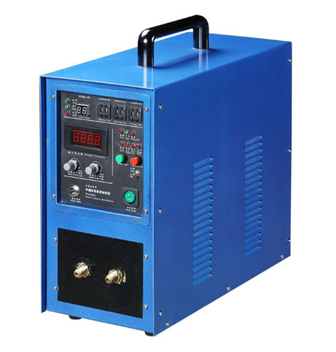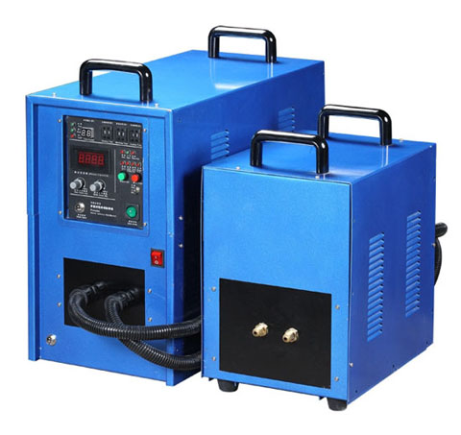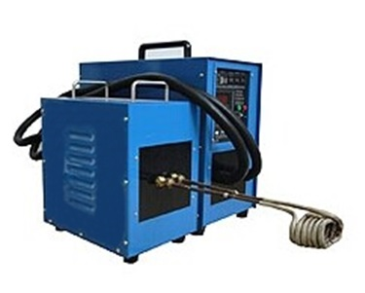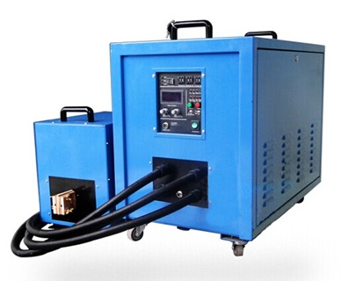
BH-15A BH-15AB BH-25A BH-25AB BH-40KW&60KW&80KW&100KW

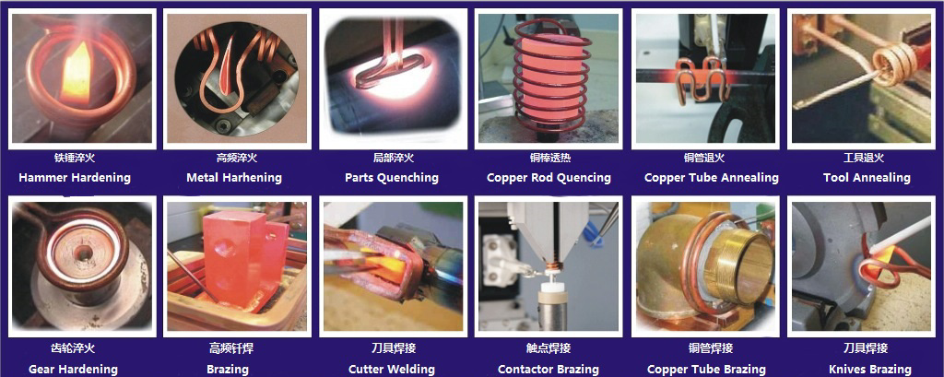
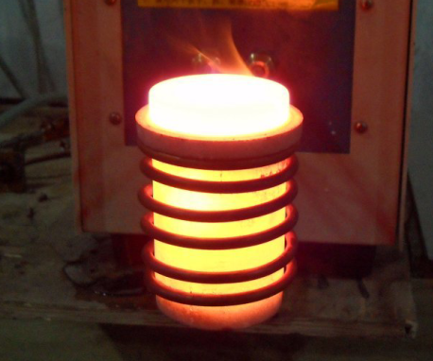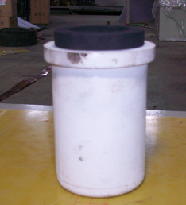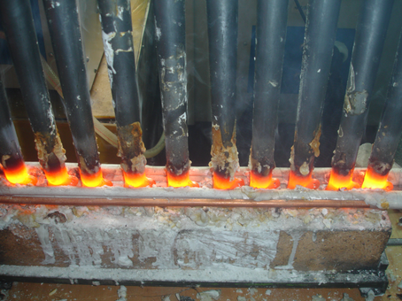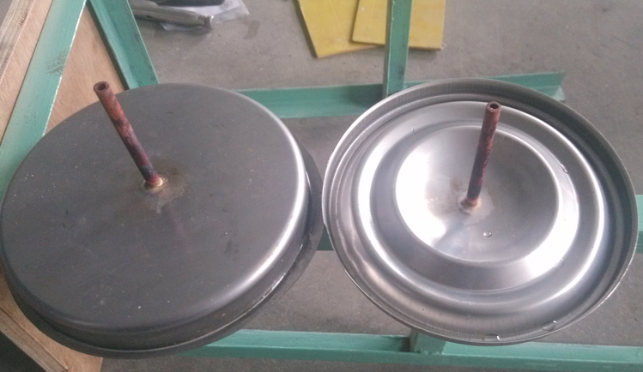
熔炼黄金 Gold Melting 熔炼坩埚Graphite Crucible 钎焊 Brazing 钎焊 Brazing

