光纤激光打标（雕刻）机系列Fiber Laser Marking (Sculpture) Machine Series
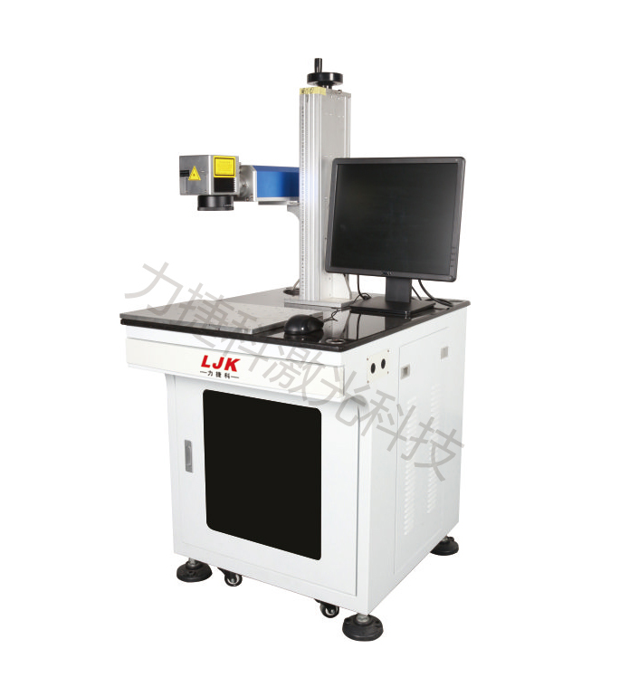
产品特点：
优势
1. 优异的光束质量：LJK-FB系列光纤激光打标机光束质量比传统的固体激光打标机好，为基模（TEMOO）输出，聚集光斑直径8um，发散角是半导体泵浦激光器的1/4，特别适用于精密、精细打标。
2. 镭雕效果好：彻底颠覆打标机不能把氧化铝直接镭雕成表面黑色的说法----能快速把氧化铝产品镭雕出丝印一样美观的表面纯黑色，不需要添加任何药水等辅助材料。
3. 使用成本低廉：电光转换效率最高达到30%，整机耗电不到500W，是灯泵浦固体激光打标机的1/10，大大节省能耗支出。
4. 免维护操作：激光器无需进行任何维护，也不用调整或清洁镜片。
5. 使用寿命长：使用激光二极管作为泵浦源，其平均工作时间可达100000小时。
6. 加工速度快：加工速度是传统激光打标机的2-10倍。
ADVANTAGES
1. Excellent beam quality: The beam quality of the LJK-FB series fiber laser marking machine is better than that of the traditional solid-state laser marking machine. It is the output of the fundamental mode (TEMOO). The concentrated spot diameter is 8um, and the divergence angle is 1/4 of that of semiconductor-pumped laser. It is especially suitable for precision and fine marking.
2. Good laser engraving effect: It completely overturns the notion that the marking machine cannot carve alumina oxide directly into black surface - it can quickly carve alumina products into pure black surface as beautiful as screen printing, without adding any auxiliary materials such as medicines.
3. Low cost and low power consumption.
4. Maintenance-free: The laser does not require any maintenance and does not require adjustment or cleaning of the lens.
5. Long service life: Using a laser diode as the pump source, the average working time is up to 100,000 hours.
6. High marking speed: The processing speed is 2-10 times that of the traditional laser marking machine.

详细介绍
应用领域
广泛应用于电工电器、电子通讯、汽车摩托车配件、精密五金、礼品饰品、眼镜钟表、仪器仪表和卫浴洁具等行业。
APPLICATIONS
It is widely used in electrical and electrical appliances, electronic communications, automotive and motorcycle accessories, precision hardware, gift jewelry, glasses and clocks, instrumentation and sanitary ware and other industries.

技术参数TECHNICAL PARAMETERS
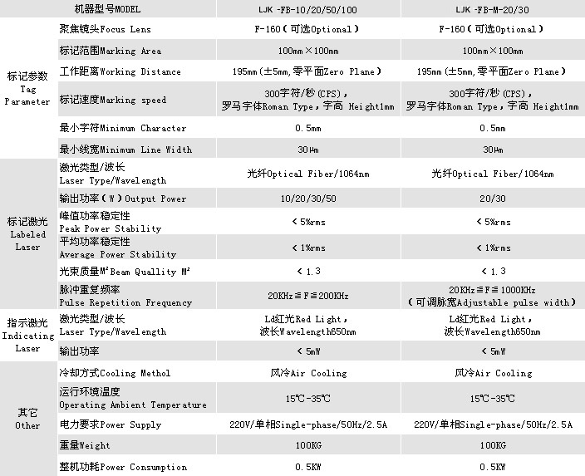

加工效果EFFECTS

