特氟龙高温胶带

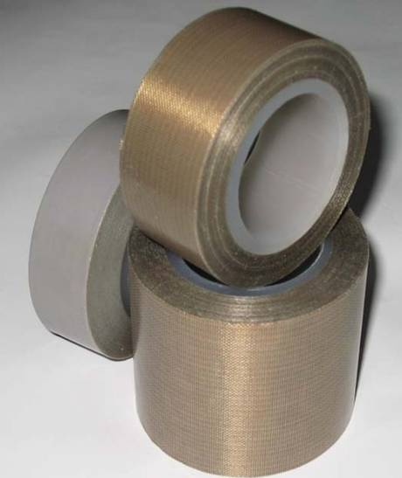 | 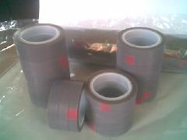
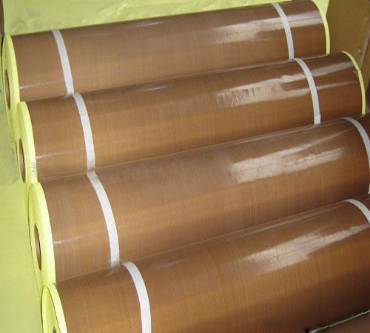
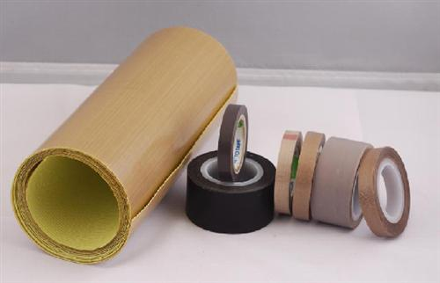 | 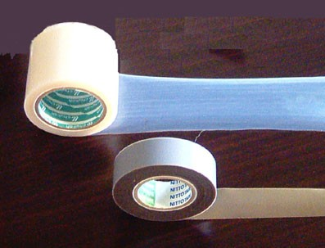
特氟龙高温胶带是选用进口玻璃纤维编织的各种基布,再涂覆进口聚四氟乙烯.,经过特殊工艺加工而成。它是一种高性能、多用途的复合材料新产品。因其优异的各项性能,故被广泛应用在造纸、食品、环保、印染、服装、化工、玻璃、医药、电子、绝缘、砂轮切片、机械等领域。一般情况下长度为10米一卷，也可定做其他长度规格。）

特氟龙胶带分为以高温布为基材的铁氟龙玻璃纤维胶带和纯铁氟龙胶带
特氟龙胶带的特点：
1、耐高温，防腐能力强（可用于染布坊）
2、表面防粘性好（脱模使用）
3、粘性好，使用时间长，曾做过实验将宽4cm胶带贴在钢板上，需要18N至22N力才能将其拉开。（粘性大小可根据顾客需要定做）。
特（铁）弗龙高温胶带主要应用范围：
A：各类高温滚筒的贴覆，加热平板、脱膜工件。
B：食品、药品和塑料袋热封。
C：滑槽，料斗，航空模具等衬垫粘贴，也可应用于浆纱机的滚筒，热塑脱模等行业，可反复使用，易于更换。
D：适合其它需要防粘，耐腐蚀和耐高温的表面处理。
E：用于包装，热塑，复合，封口热合，电子电气等行业。
特（铁）弗龙高温胶带主要规格：
厚度：0.08 mm,0.13 mm,0.15 mm,0.18 mm,0.25 mm,0.35mm,0.4mm,0.5mm，其他特殊规格可定做
宽度：9-1250 mm 可以进行小规格高精度分切
长度：10-50 M
颜色：棕色、咖啡色、黑色。也可按客户需求定做

主要规格Main Specification:
- 织物加强型的特氟龙PTFE玻璃玻璃纤维布胶带系列
PTFE coated fiberglass adhesive fabric series
型号  Model | 厚度Thickness |  | 最大宽度  Max Width | 粘附强度（对刚）Adhesion(to steel) | 抗拉强度Tensile Strength | 耐温范围  Temperature Range
型号  Model | mm | mil
XJ-T7008 | 0.08 | 3.0 | 1250mm | 22N/100mm | 900N/100mm | -70~260℃
XJ-T7013 | 0.13 | 5.0 | 1250mm | 28N/100mm | 1700N/100mm | -70~260℃
XJ-T7018 | 0.18 | 7.0 | 1250mm | 48N/100mm | 2750N/100mm | -70~260℃
XJ-T7025 | 0.25 | 10.0 | 1250mm | 62N/100mm | 3650N/100mm | -70~260℃
- 纯特氟龙胶带
Pure PTFE adhesive tape
型号  Model | 厚度Thickness |  | 最大宽度  Max Width | 粘附强度（对刚）Adhesion(to steel) | 抗拉强度Tensile Strength | 耐温范围  Temperature Range
型号  Model | mm | mil
XJ-S7005 | 0.05 | 3.0 | 1000mm | 20N/100mm | 300N/100mm | -70~260℃
XJ-T7013 | 0.13 | 5.0 | 1000mm | 25N/100mm | 400N/100mm | -70~260℃
XJ-T7018 | 0.18 | 7.0 | 1000mm | 44N/100mm | 650N/100mm | -70~260℃
XJ-T7025 | 0.25 | 10.0 | 1000mm | 58N/100mm | 950N/100mm | -70~260℃
- 硅胶布粘胶带，基布为硅橡胶覆合玻璃纤维布，背面是硅胶粘胶，标准厚度0.2毫米，其它厚度也可以提供。
Silicone fiberglass fabric with adhesive backside, use silicone fiberglass fabric as basic cloth , silicone adhesive on backside, standard thickness is 0.20mm, other thicknesses are also available.
- 其它F46膜胶带，PFA及FEP胶带等。
Several other types are also available ,such as PFA, FEP adhesive tape,etc.

Teflon Coated Fabricglass Silicon Adhesive Tape and Teflon Film Silicon Adhesive Tape
Teflon coated glassfabric tape: Imported fiber glass woven fabric or pure PTFE film,both of which are coated with imported PTFE.It is a high performance, multi-use new product. By its excellent performance, it is widely used in papermaking, food, environmental protection, printing&dyeing, apparel, chemicals, glass, pharmaceuticals, electronics, insulation, grinding wheel, machinery and other fields. A roll of this tape is usually 10 meters in length.(other lengths can also be customized. )

Features of Teflon Silicon Adhesive Tape:
1.High temperature resistable,strong anti-corrosion property(by this advantage,it can be used for dyeing)
2. Good anti-stick property on surface (by this,it can be used for demoulding)
3, Good viscosity, long service time. 18N to 22N force is needed to remove a 4cm width belt which is adhered to steel plate. (Coefficient of viscosity can be customized according to different requirements).

Application of PTFE coated tape:
A:As coatings of high-temperature roller, heating plate, demoulding unit.
B: Heat-sealing materials for food, medicines and plastic bag.
C: As gaskets of trough, hopper, aviation molds.
D: Other fields in which surface treatment is needed to reach anti-stick,anti-corrosion and high temperature resistance properties.
E: For packaging, thermoplastic, composites, heat sealing, electrical and electronic industries.

Specifications of PTFE coated tape:
Thickness: 0.08 mm, 0.13 mm, 0.15 mm, 0.18 mm, 0.25 mm, 0.35mm, 0.4mm, 0.5mm, and other special specifications.
Width:9-1250 mm width.
Length:10-50 m.
Colors: brown, brown, black and other colors.

